Twisted Tornadoes
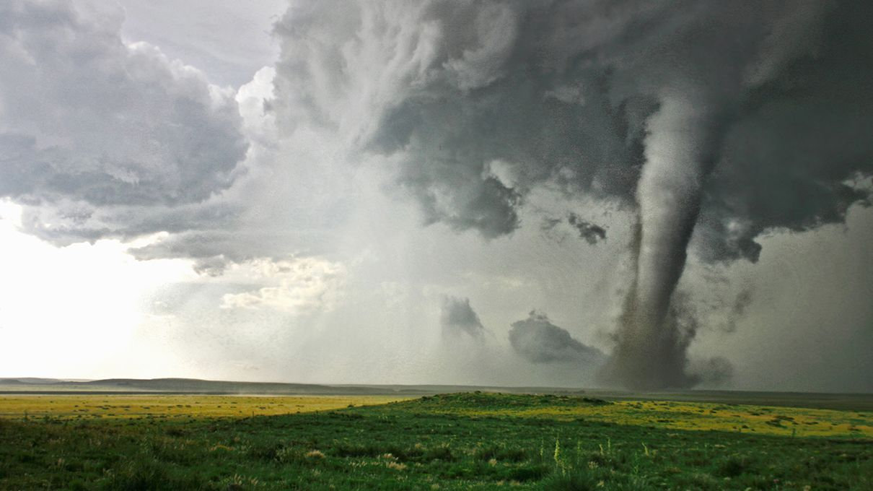
Have you ever wondered what happens when the Earth gets angry? In this report, you will discover fascinating facts all about ‘Tornadoes’ and how they cause destruction in many countries around the world.

What is a Tornado?
A tornado is a violent rotating column of air extending from a thunderstorm to the ground. The most violent tornadoes are capable of tremendous destruction with wind speeds of up to 300 mph. They can destroy large buildings, uproot trees and hurl vehicles hundreds of yards. They can also drive straw into trees. Damage paths can be in excess of one mile wide to 50 miles long. In an average year, 1000 tornadoes are reported nationwide across the United States.
How do tornadoes form?
Most tornadoes form from thunderstorms. You need warm, moist air from the Gulf of Mexico and cool, dry air from Canada. When these two air masses meet, they create instability in the atmosphere. A change in wind direction and an increase in wind speed with increasing height creates an invisible, horizontal spinning effect in the lower atmosphere. Rising air within the updraft tilts the rotating air from horizontal to vertical. An area of rotation, 2-6 miles wide, now extends through much of the storm. Most strong and violent tornadoes form within this area of strong rotation.
Did you know?
- Tornadoes can occur at any time of the year.
- 69% of all tornadoes are labelled "weak tornadoes" meaning they have a lifetime of 1-10+ minutes and winds less than 110 mph.
- 2% of all tornadoes are labelled "violent tornadoes" and can last over an hour.
- Fujita–Pearson scale (FPP scale), is a scale for rating tornado intensity.
What do tornadoes look like?
Tornadoes can appear as a traditional funnel shape, or in a slender rope-like form. Some have a churning, smoky look to them, and others contain "multiple vortices", which are small, individual tornadoes rotating around a common centre. Others may be nearly invisible, with only swirling dust or debris at ground levels as the only indication of the tornado's presence.

