DATE | Reading | Spelling/Writing | Mathematics | Topic
Monday 22nd February  . Live zoom with Mrs Doe at 9.30am  Click on the link below to join. | 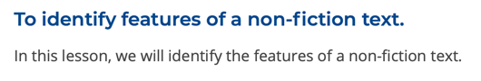  Rushing Rivers by Kingfisher  https://teachers.thenational.academy/units/rushing-rivers-by-kingfisher-ea96#  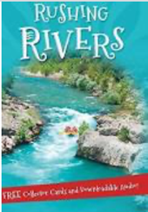 | SPELLING – linked to our new topic on rivers.  Current  Delta  Complete the table  Deposit  Discharge  Downstream  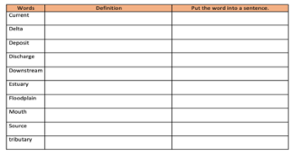  Erosion  Estuary  Floodplain  Mouth  Sediment  Source  tributary  SPaG  What are modal verbs?  https://www.bbc.co.uk/bitesize/topics/zwwp8mn/articles/zps4pbk  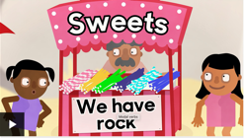  Modal verbs  These are verbs that indicate likelihood, ability, permission or obligation.  Words like: can/could, may/might, will/would, shall/should and must.  "The Sea Monster should go away"  'Should' is the modal verb here as it indicates the likelihood of the Sea Monster going away.  Go through the quiz  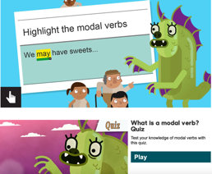 | Mathletics or the suggested links below – fractions.  https://www.topmarks.co.uk/maths-games/7-11-years/fractions-and-decimals  https://uk.splashlearn.com/fraction-games | Watch the online recorded lesson of Mrs Doe.  https://www.loom .com/share/8a2a1 4a634644950be2c fbf05cdced09  This is the first lesson of our new geography topic. Our main question this term is:  What are the significant rivers of the world and why are they important?  In this lesson we will be focusing on:  What are the main rivers around the world?  What are the names and locations of some main countries?  What are the names and locations of some of the main cities of the world?  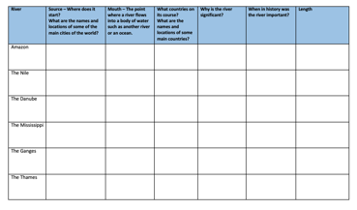

Geography ideas:
https://www.natgeokids.com/uk/?s=rivers&post_type=
https://www.bbc.co.uk/bitesize/search?q=rivers
English ideas:
https://www.literacyshed.com/story-starters.html
Online dictionary -https://kids.wordsmyth.net/we/
Pobble 365 Writing activities https://www.pobble365.com/
Maths ideas:
Pixl –practise tables using the App
Nrich -https://nrich.maths.org/primary
Worksheets to practise tables: http://www.snappymaths.com/
Keeping active:
Cosmic kids yoga –mainly on Youtube check with an adult
GoNoodle -https://app.gonoodle.com/
The Woodland trust - https://www.woodlandtrust.org.uk/support-us/act/your-school/resources/
Joe Wicks daily work out

