DATE | Reading | Spelling/Writing | Mathematics | Topic
Monday 1st March  . Live zoom with Mrs Doe at 9.30am | 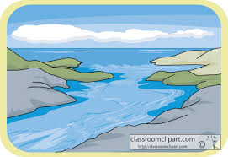  Read the following text or watch the online recorded lesson of Mrs Doe.  https://www.loom.com/share/9e4289e08df34e308331261585093162  Non-chronological  report Rivers  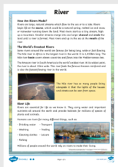  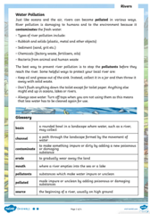 | Spelling  To investigate more prefixes  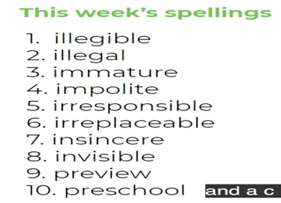  We will learn about the prefixes 'il', 'im', 'in', 'ir' meaning 'not' and learn about the prefix contained in the word 'prefix'.  https://teachers.thenational.academy/units/prefixes-un-dis-mis-in-il-im-ir-re-sub-inter-super-anti-auto-bi-trans-tele-circu#  SPaG  - A quotation is a phrase taken directly from a text or speech.  - Points you make about a text should be supported by short quotations from the text.  - There are different ways of using a quotation within the structure of a sentence or paragraph.  - It’s important to carefully punctuate your quotations, so that the meaning is clear  Watch the KS3 short video.  https://www.bbc.co.uk/bitesize/topics/zr6bxyc/articles/zn2n8xs | Mathletics or the suggested links below – fractions.  https://www.topmarks.co.uk/maths-games/7-11-years/fractions-and-decimals  https://uk.splashlearn.com/fraction-games | This term one of the areas of learning in computing is:  To communicate (Choose the most suitable apps and devices for the purposes of communication, use many of the advanced features in order to create high quality, professional or efficient communications)  So, we are asking you all to send us a message on Seesaw it would be great if you could upload a photo or video too. It could be of something you did in half term or just the latest book you are reading. Or you could tell us about what you are looking forward to as we start to come out of lockdown.

Geography ideas:
https://www.natgeokids.com/uk/?s=rivers&post_type=
https://www.bbc.co.uk/bitesize/search?q=rivers
English ideas:
https://www.literacyshed.com/story-starters.html
Online dictionary -https://kids.wordsmyth.net/we/
Pobble 365 Writing activities https://www.pobble365.com/
Maths ideas:
Pixl –practise tables using the App
Nrich -https://nrich.maths.org/primary
Worksheets to practise tables: http://www.snappymaths.com/
Keeping active:
Cosmic kids yoga –mainly on Youtube check with an adult
GoNoodle -https://app.gonoodle.com/
The Woodland trust - https://www.woodlandtrust.org.uk/support-us/act/your-school/resources/

