School Closure Daily Planning- Crystal Class Week 5
DATE | Reading | SPaG/Writing | Mathematics | Topic
Friday 5.2.21  Mrs Doe’s weekend message. | Reading  Answer the questions from Crystal Class.  How did you do?  PSHE  Watch the online recorded lesson of Mrs Doe.  https://www.loom.com/share/0055f5e7ae1f490085665b34a74704a7  Being at home more than usual may mean you are going online more than usual.  Have a go at this game (Bandrunner) which tests your e-safety knowledge.  https://www.thinkuknow.co.uk/8_10/  When you have finished, write a list of Top Tips for keeping safe online based on what you saw in the game.  Add in illustrations too, if you have large paper at home, you could make it as a poster.  Why not present your Top Tips as a podcast or a video and send it to me via Seesaw. | 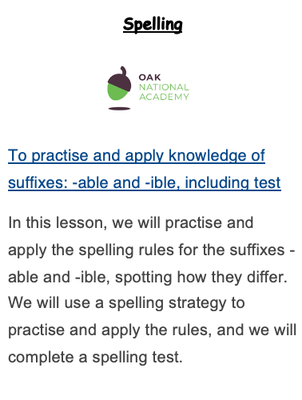  Click on the link below.  https://teachers.thenational.academy/units/suffixes-able-ible-fc0c#  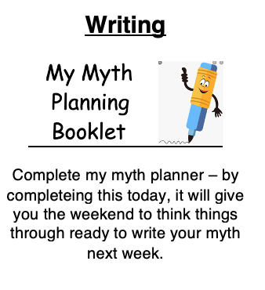 | Train Time Worksheet  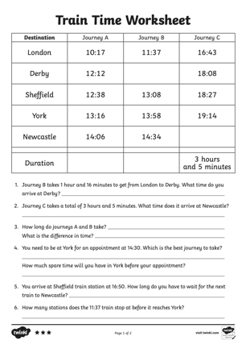  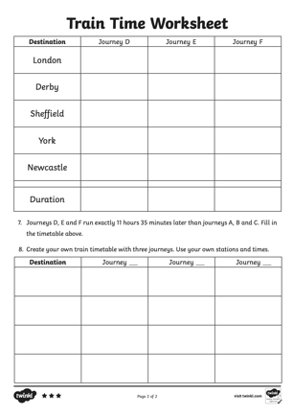 | Chance to shine lesson 3 -  Click on the link below.  https://youtu.be/btflr02RzmE

Other useful websites:
English ideas:
https://www.literacyshed.com/story-starters.html
Online dictionary -https://kids.wordsmyth.net/we/
Pobble 365 Writing activities https://www.pobble365.com/
Maths ideas:
Pixl –practise tables using the App
Nrich -https://nrich.maths.org/primary
Worksheets to practise tables: http://www.snappymaths.com/

Keeping active:
Cosmic kids yoga –mainly on Youtube check with an adult
GoNoodle -https://app.gonoodle.com/
The Woodland trust - https://www.woodlandtrust.org.uk/support-us/act/your-school/resources/
Joe Wicks daily work out

CBBC: has lots of programmes from ‘Horrible Histories’ to ‘Operation Ouch’

