School Closure Daily Planning- Crystal Class Sp 4 Week 1
DATE | Reading | SPaG/Writing | Mathematics | Topic
Friday 26th February  Live zoom with Mrs Doe at 9.30am | 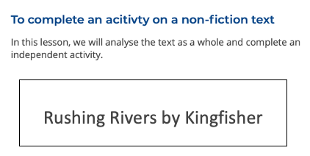  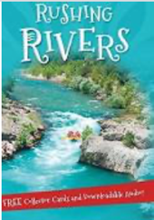  https://teachers.thenational.academy/units/rushing-rivers-by-kingfisher-ea96# | Watch the online recorded lesson of Mrs Doe.  https://www.loom.com/share/ba5b5f3f71ed4f9eadc2e74fa4d5770f  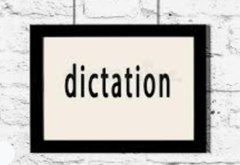  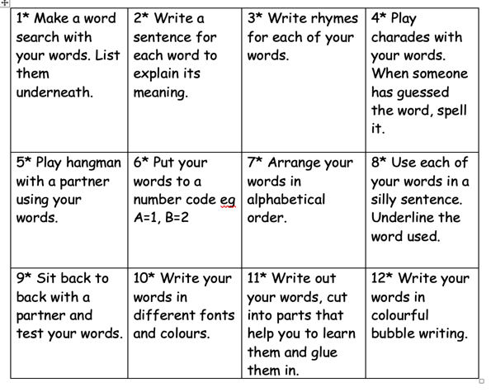  Dictation time  Watch my recorded live lesson for your dictated sentences. | Recap Fractions greater than 1  Video  https://vimeo.com/498362964  Teaching slides  https://resources.whiterosemaths.com/wp-content/uploads/2021/01/Spr5.4.4-Fractions-greater-than-1.pptx  True or False  https://resources.whiterosemaths.com/wp-content/uploads/2020/01/T-or-F-Year-4-Spring-B3-S4-Fractions-greater-than-1.pdf  Worksheet  https://resources.whiterosemaths.com/wp-content/uploads/2019/12/Y4-Spring-Block-3-WO4-Fractions-greater-than-1-2019.pdf  Answers  https://resources.whiterosemaths.com/wp-content/uploads/2019/12/Y4-Spring-Block-3-ANS4-Fractions-greater-than-1-2019.pdf | Chance to shine  Week 5 - Ferocious Fielder  https://www.youtube.com/watch?v=uZJ609at838  Friday fun!  Draw with Rob  http://www.robbiddulph.com/draw-with-rob

Other useful websites:
Geography ideas:
https://www.natgeokids.com/uk/?s=rivers&post_type=
https://www.bbc.co.uk/bitesize/search?q=rivers
English ideas:
https://www.literacyshed.com/story-starters.html
Online dictionary -https://kids.wordsmyth.net/we/
Pobble 365 Writing activities https://www.pobble365.com/
Maths ideas:
Pixl –practise tables using the App
Nrich -https://nrich.maths.org/primary
Worksheets to practise tables: http://www.snappymaths.com/

Keeping active:
Cosmic kids yoga –mainly on Youtube check with an adult
GoNoodle -https://app.gonoodle.com/
The Woodland trust - https://www.woodlandtrust.org.uk/support-us/act/your-school/resources/
Joe Wicks daily work out

CBBC: has lots of programmes from ‘Horrible Histories’ to ‘Operation Ouch’

