School Closure Daily Planning- Crystal Class Week 6
DATE | Reading | SPaG/Writing | Mathematics | Topic
Friday 12th February  Live zoom with Mrs Doe at 9.30am | Reading  Answer the questions – How did you do?  If you got any wrong please have another go at trying to answer it correctly.  Now choose one of the activities below.  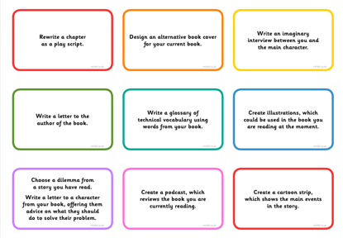 | Spelling  To practise and apply knowledge of compound words, including test  In this lesson, we will practise and apply our knowledge of compound nouns.  https://classroom.thenational.academy/lessons/to-practise-and-apply-knowledge-of-compound-words-including-test-71h32d | 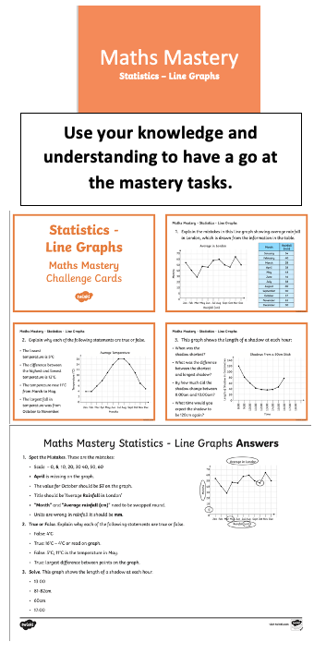 | Chance to shine  Week 4 - Brilliant Bowler  Click on the link below.  https://www.youtube.com/watch?v=LXaOhzKQrmg  https://www.chancetoshine.org/live  Friday fun!  Draw with Rob  http://www.robbiddulph.com/draw-with-rob

Other useful websites:
English ideas:
https://www.literacyshed.com/story-starters.html
Online dictionary -https://kids.wordsmyth.net/we/
Pobble 365 Writing activities https://www.pobble365.com/
Maths ideas:
Pixl –practise tables using the App
Nrich -https://nrich.maths.org/primary
Worksheets to practise tables: http://www.snappymaths.com/

Keeping active:
Cosmic kids yoga –mainly on Youtube check with an adult
GoNoodle -https://app.gonoodle.com/
The Woodland trust - https://www.woodlandtrust.org.uk/support-us/act/your-school/resources/
Joe Wicks daily work out

CBBC: has lots of programmes from ‘Horrible Histories’ to ‘Operation Ouch’

