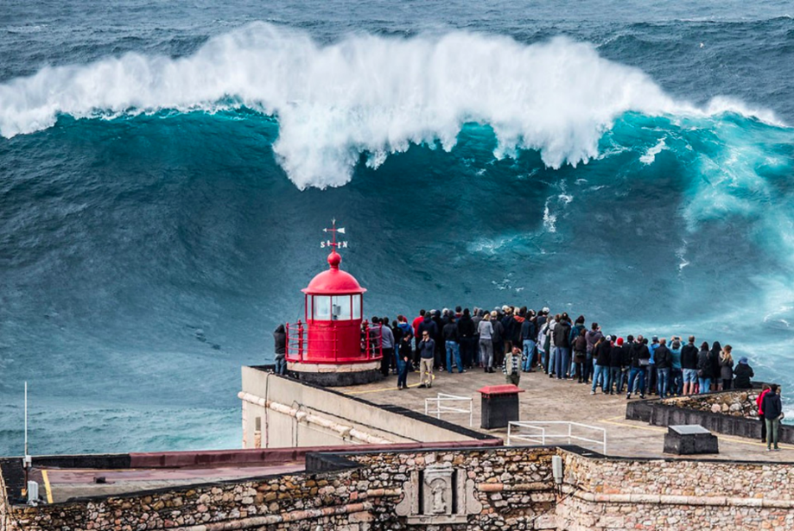

Question time! Please discuss the answers with someone near you
Where will the wave break?
Will it breach the sea wall?
How do you think you would feel if you were standing there?
What might be behind the wave?
Exploring similes
Writers often use similes to make their writing richer and give the reader a good picture of what's being described. They compare one thing with another using as or like.
For example:
- As cold as ice
- Swim like a fish
- As light as a feather
- As cool as a cucumber
- Can you think of any more?

1.Can you identify the similes in the writing below?
Some people love living dangerously. For some people, the thrill of a near miss is what they crave their whole lives; the moment of panic that rises up from the pit of your stomach like your blood has turned to ice, but then washes over you as blissful as warm water until the danger passes.
This was one of those moments. You could hear the sharp intake of breath as the crest of the fifty metre wave frothed and foamed like the mouth of an angry Kraken. There were only seconds left to wait...

2.Can you write a paragraph to describe the wave, including one or two similes?

Words that might help you:
Powerful
Tower
Wall
Escaped
Ran
Charged
Power
Roar
Brave

