School Closure Daily Planning- Garnet Class
DATE | Reading | Writing | Mathematics | Topic
Wednesday 10th February  10.2.21  Story:  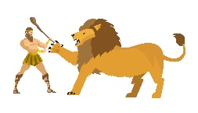  The Twelve labours of Hercules | Listen to the text with Mrs Duffield  Read and understand a text  Discover Athens  Can you read the text once more and then:  Can you discuss the text with someone near you?  What is the text about?  Can you highlight any unknown words? What do they mean?  What kind of text is it?  How do you know?  What do you like/dislike about the text? | Plan a travel brochure on the city of Athens –  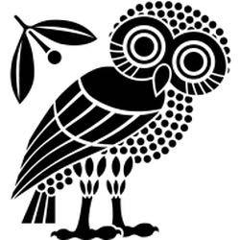  Listen to Mrs Duffield talk about travel brochures.  Please check with an adult when searching for images of Athens.  https://www.loom.com/share/fb9e95e87eba404abed81b2905ff2251  Watch the touring teacher talk about the city of Athens and all the exciting places to visit.  https://www.youtube.com/watch?v=5I0_EUcaU9Q  Can you make notes on the city?  You can use the reading text ’Discover Athens’ too.  Can you begin to design and create your own brochure? You can do this as PowerPoint, in word or on paper. You will need to find lots of interesting pictures and remember to ask an adult to help you to search for the images. Remember to include that it is for KS2 in your search bar.  The travel brochure:  https://issuu.com/www.visitgreece.gr/docs/citybreak_2018?e=16838025/67318876 | White rose Maths  Counting squares  Please watch the video and follow the link to:  https://whiterosemaths.com/homelearning/year-4/spring-week-4-measurement-area/  Please complete the work sheets  Extension  True or False and Extension | What is Karneval in Germany?  Mrs Duffield talks about Karneval in Germany.  Please follow the link to:  https://www.loom.com/share/28a1e70aff9b4552b1727dc8c52e6ec2  Design your own Karneval costume  If you had the chance to go to a Karneval celebration in Germany, what would you wear?  Can you design your very own Karneval costume. What would you choose to wear? Would you be a character from a film or a knight or a princess?

https://www.literacyshed.com/story-starters.html
Online dictionary https://kids.wordsmyth.net/we/

Maths ideas:
Pixl –practise tables using the App
Nrich -https://nrich.maths.org/primary
Worksheets to practise tables: http://www.snappymaths.com/

Keeping active:
Cosmic kids yoga –mainly on Youtube check with an adult
GoNoodle -https://app.gonoodle.com/
The Woodland trust - https://www.woodlandtrust.org.uk/support-us/act/your-school/resources/
Joe Wicks daily work out

CBBC: has lots of programmes from ‘Horrible Histories’ to ‘Operation Ouch’

