School Closure Daily Planning- Garnet Class
DATE | Reading | Writing | Mathematics | Topic
Tuesday 2nd February  2.2.21  Class story  Theseus and the Minotaur | Ask questions to understand the text.  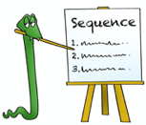  Can you discuss the text with someone near you?  What is the text about?  Can you highlight any unknown words? What do they mean?  What kind of text is it?  How do you know?  What do you like/dislike about the text?  Can you find one key fact from each paragraph? Can you hightlight or underline your key fact? | Watch the video and walk around the ancient city of Athens.  Follow the link to:  https://www.loom.com/share/939c6527a23348d3b4d3d4de10fd8155  On your journey make a note of all the different jobs –you may have to pause the video to gather the information.  Can you:  1. Write a list of the jobs you see.  2.On your list can you highlight or underline jobs which we still do today  3.Can you choose which job you would like and why it appeals to you.  4. Imagine you have a job working in Ancient Athens and you need a new assistant. Can you write a job advert to help you find someone suitable.  Can you write a brief job description  Can you think of the skills they might need?  The hours they will they will have to work.  Use the template to help you with your writing. Remember to think about presentation, using a range of sentences and punctuation. | White rose maths  Multiply 2- digits by 1-digit  Please follow the link and watch the video  https://whiterosemaths.com/homelearning/year-4/spring-week-2-number-multiplication-division/  True or False and extension  Please complete the True or False questions and the extension.  Pixl tables –practise a tricky table. | Cricket  Chance to Shine, lesson 3  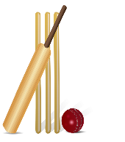  https://www.youtube.com/watch?v=btflr02RzmE  And/ or  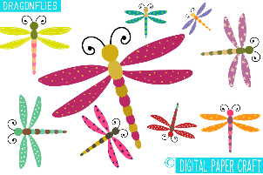  Make a paper Dragonfly from the story Pandora’s Box.  Please follow the link to:  https://www.youtube.com/watch?v=NRPYBRIDyns

https://www.literacyshed.com/story-starters.html
Online dictionary -https://kids.wordsmyth.net/we/

Maths ideas:
Pixl –practise tables using the App
Nrich -https://nrich.maths.org/primary
Worksheets to practise tables: http://www.snappymaths.com/

Keeping active:
Cosmic kids yoga –mainly on Youtube check with an adult
GoNoodle -https://app.gonoodle.com/
The Woodland trust - https://www.woodlandtrust.org.uk/support-us/act/your-school/resources/
Joe Wicks daily work out

CBBC: has lots of programmes from ‘Horrible Histories’ to ‘Operation Ouch’

