School Closure Daily Planning- Garnet Class
DATE | Reading | Writing | Mathematics | Topic
Tuesday 23rd February  23.2.21  Listen to the class story  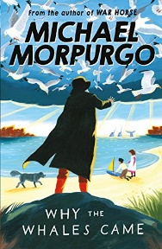 | Ask questions to understand the text.  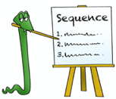  ‘United Kingdom’  Can you discuss the text with someone near you?  What is the text about?  Can you highlight any unknown words? What do they mean?  What kind of text is it?  How do you know?  What do you like/dislike about the text?  Can you find one key fact from each paragraph? Can you hightlight or underline your key fact? | 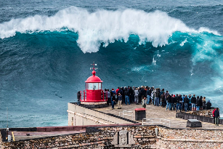  Identifying and using similes  Revising similes  Can you follow the work sheet and revise similes. Can you write a paragraph linked to the picture, remembering to include your own similes. | Key mathematical vocabulary on fractions with Mrs Duffield.  White rose maths  Unit and non-unit fractions  Please can  you watch the video and complete the work sheets. If you are finding the work challenging then try and do as much as you can.  https://whiterosemaths.com/homelearning/year-4/spring-week-5-number-fractions/  Flashback and extension  Please complete the flashback and the extension. | How London Grew  Explore London past and present and identify changes in the human geography  https://www.loom.com/share/dc99cca7862f49678425935d60627e75  Visit London through goggle earth  https://www.google.com/maps/place/England/@52.7535702,-6.8129301,6z/data=!3m1!4b1!4m5!3m4!1s0x47d0a98a6c1ed5df:0xf4e19525332d8ea8!8m2!3d52.3555177!4d-1.1743197  Draw one of the landmarks follow the link to:  https://artprojectsforkids.org/how-to-draw-the-london-towers/  or  https://artprojectsforkids.org/draw-big-ben/  Extension –use the goggle earth image to draw your own map of London

https://www.literacyshed.com/story-starters.html
Online dictionary -https://kids.wordsmyth.net/we/

Maths ideas:
Pixl –practise tables using the App
Nrich -https://nrich.maths.org/primary
Worksheets to practise tables: http://www.snappymaths.com/

Keeping active:
Cosmic kids yoga –mainly on Youtube check with an adult
GoNoodle -https://app.gonoodle.com/
The Woodland trust - https://www.woodlandtrust.org.uk/support-us/act/your-school/resources/
Joe Wicks daily work out

CBBC: has lots of programmes from ‘Horrible Histories’ to ‘Operation Ouch’

