School Closure Daily Planning- Garnet Class
DATE | Reading | Writing | Mathematics | Topic
Thursday 4th February  4.2.21  Listen to the story: Echo and Narcissus | Retrieving information from the text ’Facts about Greece’.  Please follow the lesson on how to retieve information from a text by following the link below.  Video link:  https://www.loom.com/share/2caee3af241b4486800ac8a6dfcd7196  Can you answer the questions on the sheet in full? | Edit and write out our letter  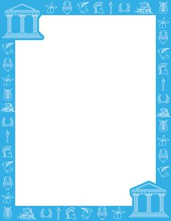  Can you please edit your letter with a purple polish pen? (Any pen is fine). Can you check that you have punctuated your sentences, checked your spellings and organised your writing into paragraphs. Can you make sure that you writing is neat and the letters are joined too. | White Rose multiply 3 digits by 1 digit  https://whiterosemaths.com/homelearning/year-4/spring-week-2-number-multiplication-division/  Still need to practise?  Please complete the sheet ‘Multiplying 2 digits by 1 digit’ sheet as an alternative maths sheet.  Extension  Please complete the extension questions | How were Greek vases made?  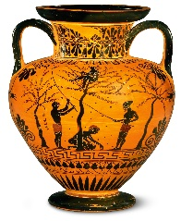  Follow the link to a video explaining the process  https://www.khanacademy.org/humanities/ap-art-history/ancient-mediterranean-ap/greece-etruria-rome/v/making-greek-vases  Draw your own Greek Vase  Follow the link to:  https://www.youtube.com/watch?v=18at687-3YY

https://www.literacyshed.com/story-starters.html
Online dictionary -https://kids.wordsmyth.net/we/

Maths ideas:
Pixl –practise tables using the App
Nrich -https://nrich.maths.org/primary
Worksheets to practise tables: http://www.snappymaths.com/

Keeping active:
Cosmic kids yoga –mainly on Youtube check with an adult
GoNoodle -https://app.gonoodle.com/
The Woodland trust - https://www.woodlandtrust.org.uk/support-us/act/your-school/resources/
Joe Wicks daily work out

CBBC: has lots of programmes from ‘Horrible Histories’ to ‘Operation Ouch’

