School Closure Daily Planning- Garnet Class
DATE | Reading | Writing | Mathematics | Topic
Thursday 25th^{th} February  25.2.21  Listen to Chapter 2 from our class story  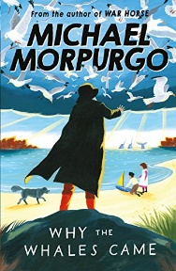 | Retrieving information from the text ’  United Kingdom  Can you answer the questions on the sheet in full?  Can you make sure that you have punctuated your sentences correctly too? | Revise Speech –The Oak Academy  Please follow the link to:  https://classroom.thenational.academy/lessons/to-revise-speech-punctuation-cngp8t  The Globe  Can you write dialogue ( a conversations between two or more people) for the brothers. See the worksheet for ideas | White Rose  Tenths  Please watch the video on Tenths and complete the work sheet.  https://whiterosemaths.com/homelearning/year-4/spring-week-5-number-fractions/  Flashback and extension  Please see the work sheet. | The Geography of England  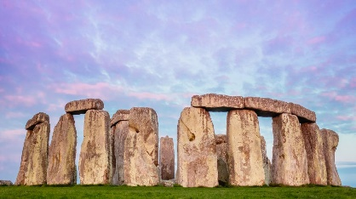  Please follow the link to find out about the geographical features  https://www.loom.com/share/6976b74b11634a8b93ad23b0b44ee082  Exploring famous Landmarks  Please follow the link to the website to find out about lots of British landmarks  Follow the link to:  https://www.teachingideas.co.uk/sites/default/files/britishlandmarkscards.pdf  Can you choose one of the landmarks and find where it is located? Can you find out more information about your landmark and create a poster persuading people to come an visit?

https://www.literacyshed.com/story-starters.html
Online dictionary -https://kids.wordsmyth.net/we/

Maths ideas:
Pixl –practise tables using the App
Nrich -https://nrich.maths.org/primary
Worksheets to practise tables: http://www.snappymaths.com/

Keeping active:
Cosmic kids yoga –mainly on Youtube check with an adult
GoNoodle -https://app.gonoodle.com/
The Woodland trust - https://www.woodlandtrust.org.uk/support-us/act/your-school/resources/
Joe Wicks daily work out

CBBC: has lots of programmes from ‘Horrible Histories’ to ‘Operation Ouch’

