School Closure Daily Planning- Garnet Class
DATE | Reading | Writing | Mathematics | Topic
Monday 8th February  8.2.21  10.00 | Listen to the text with Mrs Duffield  Read and understand a text  The Battle for Athens  Can you read the text once more and then:  Can you discuss the text with someone near you?  What is the text about?  Can you highlight any unknown words? What do they mean?  What kind of text is it?  How do you know?  What do you like/dislike about the text? | The Oak Academy spellings  Please follow the link to find out how to use  https://classroom.thenational.academy/lessons/to-investigate-more-suffixes-past-and-present-tense-64wp2c  Some of the statutory spellings too  1.February  2. difficult  3.disappear  Can you check any definitions you are not sure about and use the spelling ideas grid to practise too. | Pixl maths test  Please choose the one that suits you best.  Please complete the Pixl test  Spring week 3 and mark your answers. Please remember to have another attempt at any that may need correcting.  Tables  Practise any you find tricky including the inverse. Please use the Pixl App, Maths frame and Top marks  Practise sheet –choose the one for you. | Practise a key word with Mrs Duffield  The Oak Academy  Find out about the Golden Age of Greece  https://classroom.thenational.academy/lessons/what-was-the-golden-age-of-greece-68vpad  Can you explore the  Greek alphabet?  Can you have a go at writing your name using the Greek alphabet?  Can you write a message for someone near to work out?  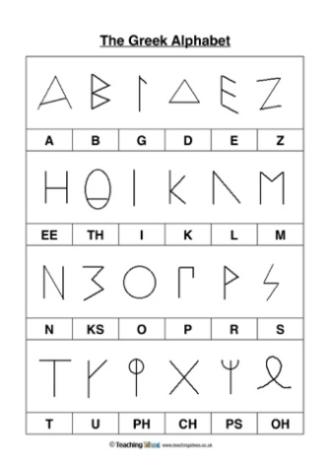

English ideas
https://www.literacyshed.com/story-starters.html
Online dictionary - https://kids.wordsmyth.net/we/

Maths ideas:
Pixl –practise tables using the App
Nrich -https://nrich.maths.org/primary
Worksheets to practise tables: http://www.snappymaths.com/

Keeping active:
Cosmic kids yoga –mainly on Youtube check with an adult
GoNoodle -https://app.gonoodle.com/
The Woodland trust - https://www.woodlandtrust.org.uk/support-us/act/your-school/resources/
Joe Wicks daily work out

CBBC: has lots of programmes from ‘Horrible Histories’ to ‘Operation Ouch’

