School Closure Daily Planning- Garnet Class
DATE | Reading | Writing | Mathematics | Topic
Monday  1st March  10.00 am  Zoom call  Be ready to play a game  Listen to the class story -pm  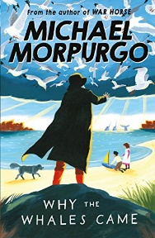 | Read and understand a text  Please listen to me read the text for this week, The Loch Ness Monster the last version –three stars  https://www.loom.com/share/5076e900a1014eb8bf22028c6c374e14  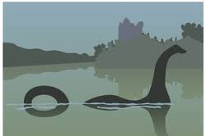  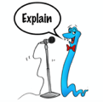  Can you have a go at ‘Echo Reading’. You can pause the video as you go along?  Echo Reading  In echo reading the teacher reads a short segment of the text –this could be a sentence or a short paragraph and the students echos it back. | The Oak Academy spellings  Please follow the link  https://classroom.thenational.academy/lessons/to-investigate-homophones-60vp2d  Some of the Statutory spellings too  - enough  - exercise  - experience  Can you check any definitions and write a sentence for each of the statutory spellings.  Extension  Can you use ideas from the spelling grid to practise? | Pixl maths test  Please choose the one that suits you best.  Please complete the Pixl test Spring week 5 and mark your answers. Please remember to have another attempt at any that may need correcting.  Times table test  Choose the sheet that suits you best  Extension  Practise using the Pixl App  Additional mathletics topics  . | Mrs Duffield discusses Scotland and surrounding islands. Please follow the link;  https://www.loom.com/share/9e59493e4a67474191cd22161349a888  Can you find out more about Tartan?  Can you write dowm 5 facts you have discovered?  Information on Tartan:  - Twinkl fact sheet  - https://kids.kiddle.co/Tartan  Can you design some tartan too?

Geography ideas:
BBC Bitesize Geography
https://www.3dgeography.co.uk/geography-topic
https://www.sciencekids.co.nz/sciencefacts/countries/england.html
https://www.ducksters.com/geography/country/united_kingdom.php

English ideas
https://www.literacyshed.com/story-starters.html
Online dictionary - https://kids.wordsmyth.net/we/

Maths ideas:
Pixl –practise tables using the App
Nrich - https://nrich.maths.org/primary

Worksheets to practise tables: http://www.snappymaths.com/

Keeping active:
Cosmic kids yoga –mainly on Youtube check with an adult
GoNoodle -https://app.gonoodle.com/
The Woodland trust - https://www.woodlandtrust.org.uk/support-us/act/your-school/resources/
Joe Wicks daily work out

CBBC: has lots of programmes from ‘Horrible Histories’ to ‘Operation Ouch’

