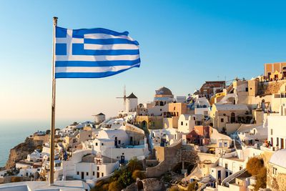
Can you answer the following questions in full?
- Where is Greece?

- Name the four countries that border Greece.

- What is summer like in Greece?

- What is the average summer temperature?
- Using information from the text can you write out the true statement?
In 2015, 26.5 million tourists visited Greece | Greece is not popular with tourists.

- When did the first Olympics take place?

