School Closure Daily Planning- Crystal Class Week 4
DATE | Reading | Writing | Mathematics | Topic
Wednesday  27.1.21  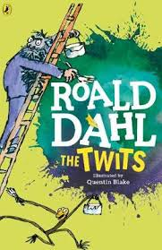  Also listen to story time with Mrs Doe. | Watch the online recorded lesson of Mrs Doe using the link below.  https://www.loom.com/share/7b56ebdcad304e1fb1e143f1fb9ec41d  Looking over the text again, highlight/copy out any new or interesting vocabulary or words you think the author has chosen for impact. Write out definitions for new and interesting vocabulary. Challenge: Why did the author choose the words for impact that he/she did? | Watch the online recorded lesson of Mrs Doe using the link below.  https://www.loom.com/share/16ec3ad2cf394735964a6898c213be2f  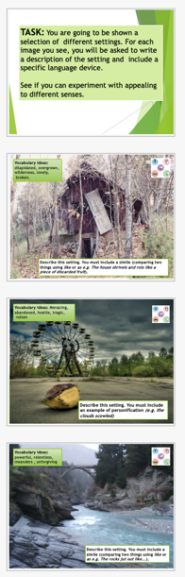  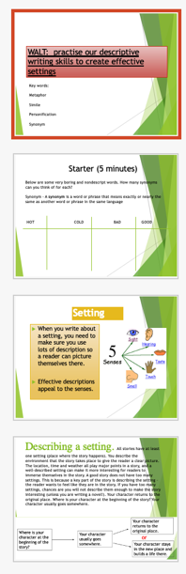  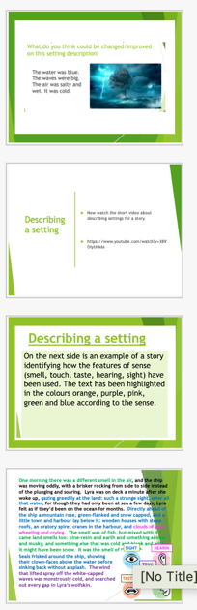  Where is your myth going to take place? | Video  https://vimeo.com/492054136  PPT  https://resources.whiterosemaths.com/wp-content/uploads/2020/12/Spr5.3.3-Divide-4-digits-by-1-digit.pptx  Activity  https://resources.whiterosemaths.com/wp-content/uploads/2019/11/Y5-Spring-Block-1-WO6-Divide-4-digits-by-1-digit-2019.pdf  Answers  https://resources.whiterosemaths.com/wp-content/uploads/2019/11/Y5-Spring-Block-1-ANS6-Divide-4-digits-by-1-digit-2019.pdf  True or False  https://resources.whiterosemaths.com/wp-content/uploads/2020/01/T-or-F-Year-5-Spring-Block-1-S6-Divide-4-digits-by-1-digit.pdf  Something a little easier  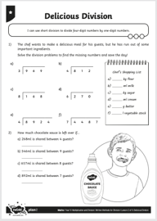  Can you answer the information sheet?  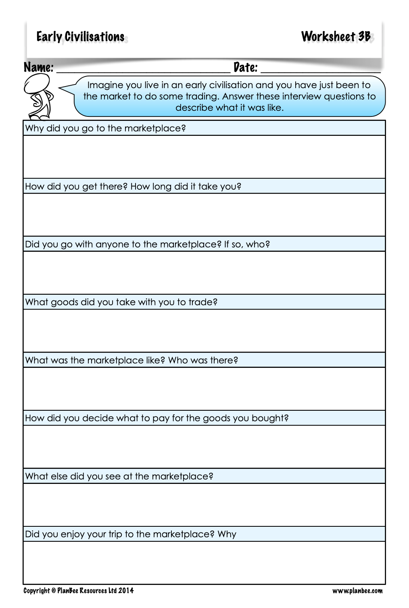  Now use your new knowledge to write a diary entry.  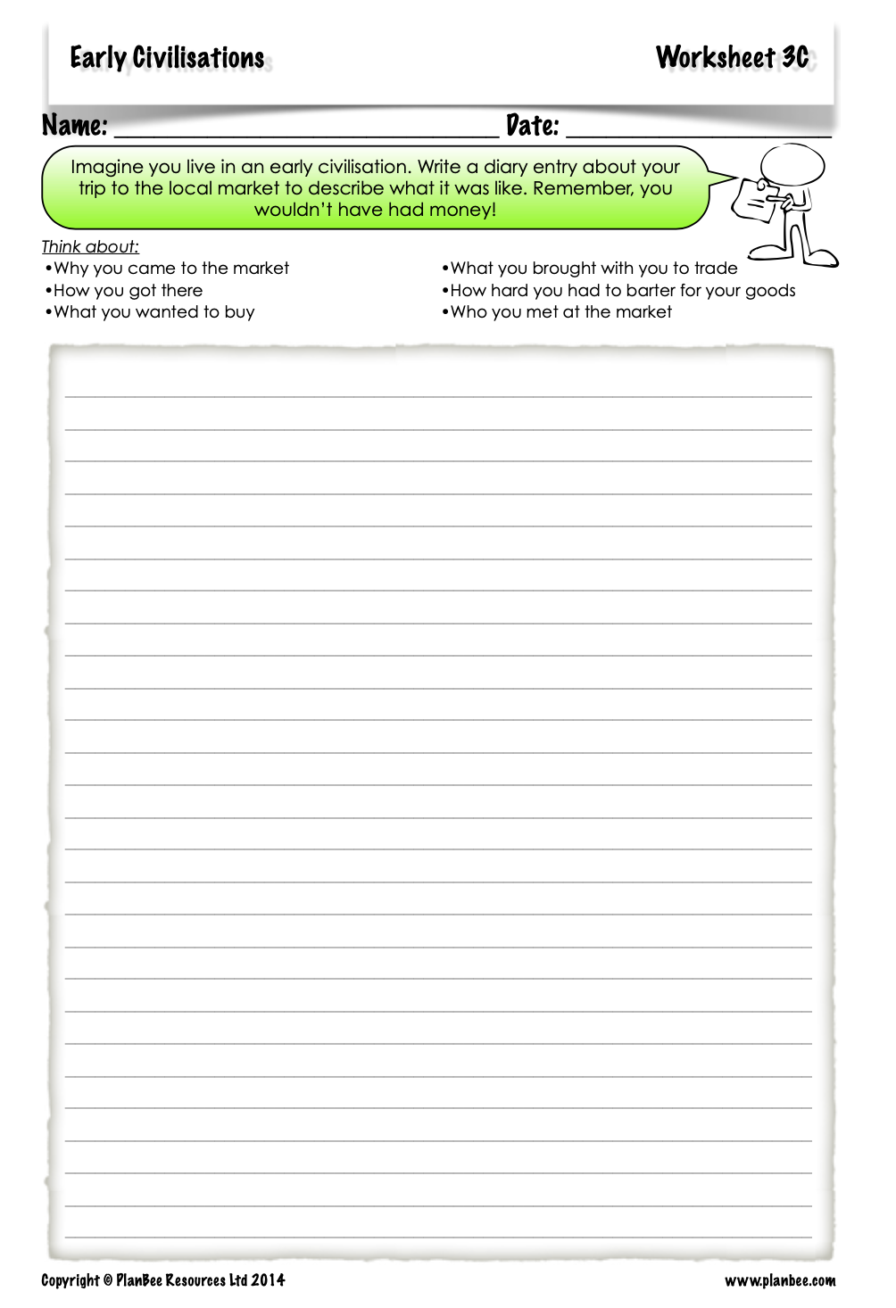  Try some more..  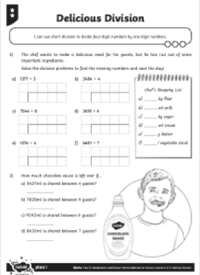  Challenge  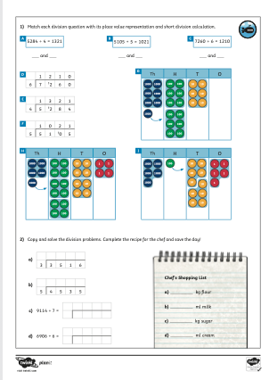 | Who were the  Sumerians?  Lesson 3 To explore  trade in early  civilisations  Go through the PPT.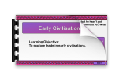  Go through the information on the slides about how people started trading once they had settled in permanent settlements and how this may be why writing developed to keep track of goods.  Now write a diray entry using your learning so far.

History ideas:
https://www.bbc.co.uk/teach/class-clips-video/history-ks2-introducing-ancient-sumer/zmgnvk7
https://www.theschoolrun.com/homework-help/ancient-sumer-and-mesopotamia
CBBC: has lots of programmes from ‘Horrible Histories’ to ‘Operation Ouch’

English ideas:
https://www.literacyshed.com/story-starters.html
Online dictionary -https://kids.wordsmyth.net/we/
Pobble 365 Writing activities https://www.pobble365.com/
Maths ideas:
Pixl –practise tables using the App
Nrich -https://nrich.maths.org/primary
Worksheets to practise tables: http://www.snappymaths.com/
Keeping active:
Cosmic kids yoga –mainly on Youtube check with an adult
GoNoodle -https://app.gonoodle.com/
The Woodland trust - https://www.woodlandtrust.org.uk/support-us/act/your-school/resources/
Joe Wicks daily work out

