School Closure Daily Planning- Crystal Class Week 3
DATE | Reading | Writing | Mathematics | Topic
Wednesday  20.1.21  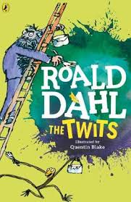  Also listen to story time with Mrs Doe. | Looking over the text again, highlight/copy out any new or interesting vocabulary or words you think the author has chosen for impact. Write out definitions for new and interesting vocabulary. Challenge: Why did the author choose the words for impact that he/she did?  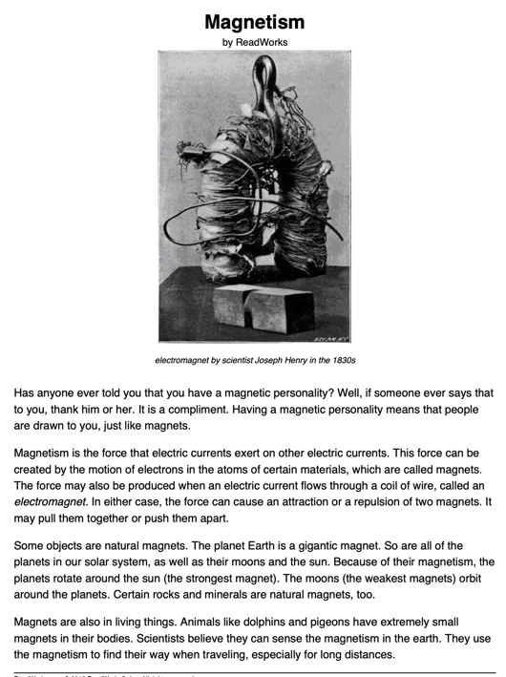 | Sentence challenge!  ‘Big’ and ‘small’ are adjectives to describe the giant and Jack. Can you think of synonyms (words that have the same or similar meaning) for ‘big’ and ‘small’?  Can you write 5 sentence to describe Jack or the giant, using some of your synonyms?  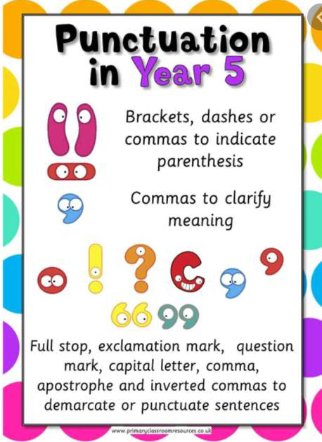  See how much punctuation you can include within your sentences. | Multiplying a 4 digit by a 2 digit.  Video  https://vimeo.com/488668598  Maths PPT  https://resources.whiterosemaths.com/wp-content/uploads/2020/12/Spr5.2.4-Multiply-up-to-a-4-digit-number-by-a-2-digit-number.pptx  True or False  https://resources.whiterosemaths.com/wp-content/uploads/2020/01/T-or-F-Year-5-Spring-Block-1-S5-Multiply-4-digits-by-2-digits.pdf  Activity  https://resources.whiterosemaths.com/wp-content/uploads/2019/11/Y5-Spring-Block-1-WO5-Multiply-4-digits-by-2-digits-2019.pdf  Answers  https://resources.whiterosemaths.com/wp-content/uploads/2019/11/Y5-Spring-Block-1-ANS5-Multiply-4-digits-by-2-digits-2019.pdf  Challenge  Generate your own sums using increasingly challenging times tables.  Something a little easier  generate your own sums using the times tables 2, 5 and 10. Then include 4 and 8 times tables. | Carry-out some research and create  a fact file, poster or PPT to show  your understanding of magnets and how  they are used in our everyday lives.  Use the reading text from last week  and all of the learning you have  already completed.  https://www.bbc.co.uk/bitesize  /topics/zyttyrd

