School Closure Daily Planning- Garnet Class
DATE | Reading | Writing | Mathematics | Topic
Weds  13.1.21 | Identify and understand new words  Can you look at the glossary? How does it help the reader?  Can you find more words to add to the glossary?  Can you use a dictionary to find the definitions  Can you create your own glossary?  Online dictionary:  https://kids.wordsmyth.net/we/ | A lesson in word classes from the Oak Academy  https://classroom.thenational.academy/lessons/to-explore-word-class-6cu3je  Watch the video and answer the questions as you go along.  At the end, when you are asked to write 5 sentences - perhaps you could write about Shackleton or Emperor penguins.  Extension  Find a sentence in your reading book. Can you identify a noun, an adjective, an adverb and a verb. Are there prepositions too. What do you notice? | White Rose Maths  Kilometres  Can you follow the video on Kilometres and complete the worksheets?  https://whiterosemaths.com/homelearning/year-4/week-8-measurement-length-perimeter/ | Visit the Antarctic using Google Earth  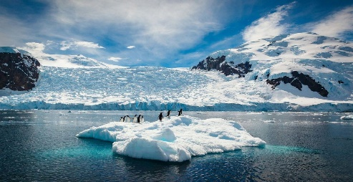  https://earth.google.com/web/search/Antarctica  Follow the link on google Earth to explore Antarctica. What can you find out? What do you notice? Can you walk around using the little yellow figure?  There are also photographs and additional information on Antarctica.  Extension  Find out about the continent of Antarctica:  Follow the link to find out more:  https://www.bbc.co.uk/bitesize/articles/z438cqt

More ideas to help with home learning
Writing ideas:
https://www.literacyshed.com/story-starters.html
Online dictionary -https://kids.wordsmyth.net/we/

Maths ideas:
Pixl –practise tables using the App
Nrich -https://nrich.maths.org/primary
Worksheets to practise tables: http://www.snappymaths.com/

Keeping active:
Cosmic kids yoga –mainly on Youtube check with an adult
GoNoodle -https://app.gonoodle.com/
The Woodland trust - https://www.woodlandtrust.org.uk/support-us/act/your-school/resources/
Joe Wicks daily work out

