School Closure Daily Planning- Crystal Class Week 2
DATE | Reading | Writing | Mathematics | Topic
Wednesday  13.1.21 | Looking over the text again, highlight/copy out any new or interesting vocabulary or words you think the author has chosen for impact. Write out definitions for new and interesting vocabulary. Challenge: Why did the author choose the words for impact that he/she did? | Story starter!  Despite being a superhero, spending the majority of his time battling against crime and dangerous villains in Gotham City with an array of different skills and deadly weapons, Batman had a weakness for chicken nuggets.  The other superheroes were also making the most of their afternoon off from saving the world. However, they didn’t have long: soon they would have to get back to business…  Continue the story. | Multiplication 4 digits by 1 digit recap  Video  https://vimeo.com/486775551  PPT  https://resources.whiterosemaths.com/wp-content/uploads/2020/12/Spr5.1.3-Multiply-4-digits-by-1-digit.pptx  True or False  https://resources.whiterosemaths.com/wp-content/uploads/2020/01/T-or-F-Year-5-Spring-Block-1-S1-Multiply-4-digits-by-1-digit.pdf  Activity  https://resources.whiterosemaths.com/wp-content/uploads/2019/11/Y5-Spring-Block-1-WO1-Multiply-4-digits-by-1-digit-2019.pdf  Answers  https://resources.whiterosemaths.com/wp-content/uploads/2019/11/Y5-Spring-Block-1-ANS1-Multiply-4-digits-by-1-digit-2019.pdf  Challenge  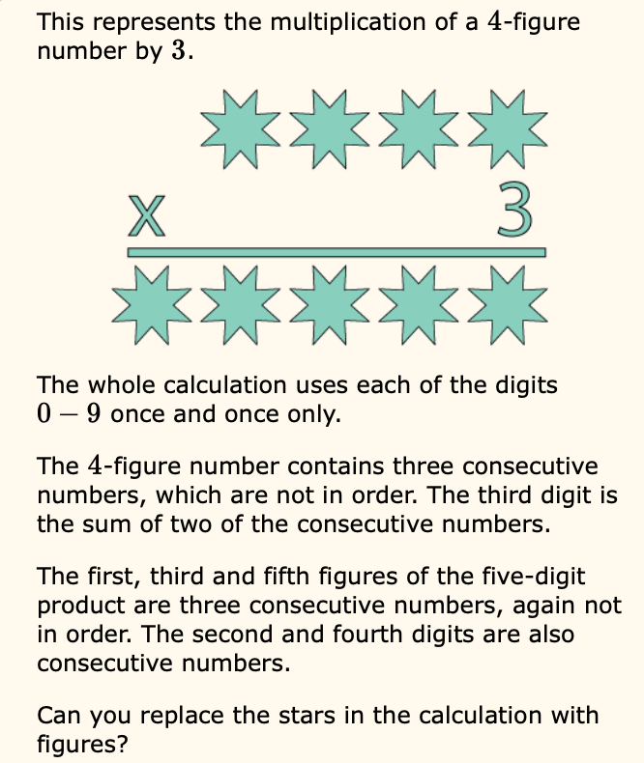  Something a bit easier  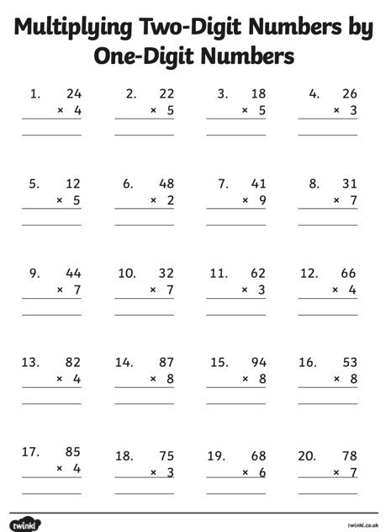 | Science – forces and magnets. Work through the attached PPT.  Complete the activity.  