School Closure Daily Planning- Crystal Class Week 4
DATE | Reading | Writing | Mathematics | Topic
Tuesday  26.1.21  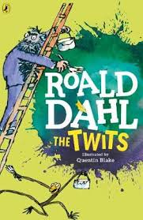  Also listen to story time with Mrs Doe. | Re-read the text from yesterday.Annotate on the text thinking about how it should sound to the audience like we do in class. Can you read it to someone in your family? Give a performance. | WALT: know the Sumerian Gods.  Watch the online recorded lesson of Mrs Doe.  https://www.loom.com/share/c2ff3a74c6c9462a9f61895c1be2e169  Read through the Sumerian Gods  fact sheets.  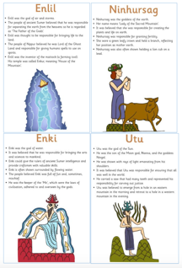 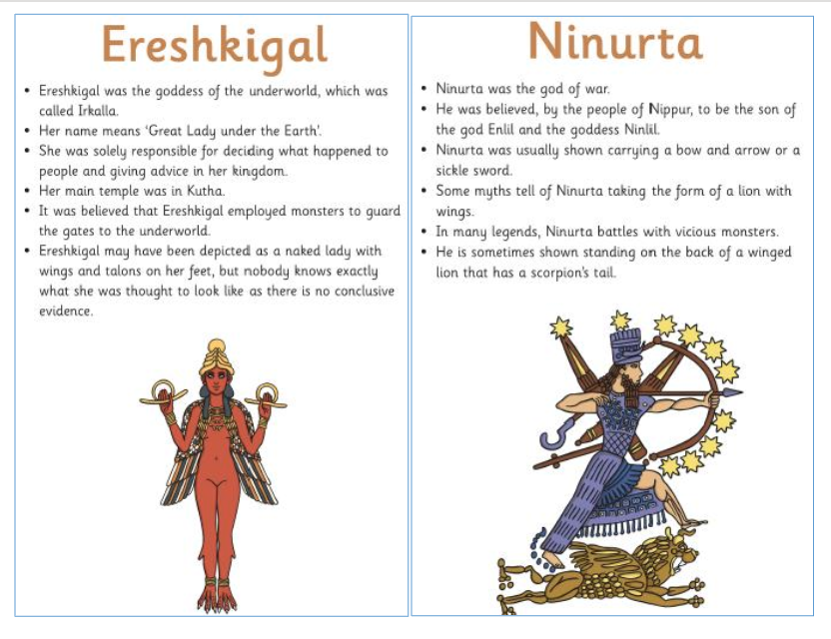  Start making a plan: decide which is  Your favourite God and how they are  going to be in your story.  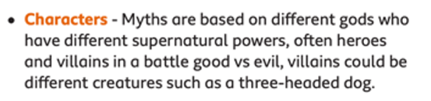  - Who are the characters in your story?  - What do they look like?  - How old are they?  - Are they a hero or a villain? Do they have a superpower? | Video  https://vimeo.com/492054040  PPT  https://resources.whiterosemaths.com/wp-content/uploads/2020/12/Spr5.3.2-Divide-3-digits-by-1-digit.pptx  True or False  https://resources.whiterosemaths.com/wp-content/uploads/2020/01/T-or-F-Year-4-Spring-Term-B1-S10-Divide-3-digits-by-1-digit.pdf  Activity sheet  https://resources.whiterosemaths.com/wp-content/uploads/2020/06/Y4-Spring-Block-1-WO10-Divide-3-digits-by-1-digit-2019.pdf  Answers  https://resources.whiterosemaths.com/wp-content/uploads/2020/06/Y4-Spring-Block-1-ANS10-Divide-3-digits-by-1-digit-2019.pdf  . | Who were the Sumerians?  Lesson 2 -To find out about the first writing systems.  After reading through the information PPT, answer the final questions, then complete the task attached.  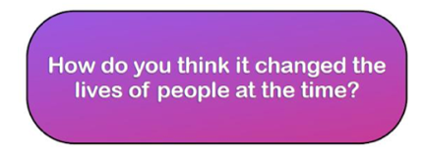  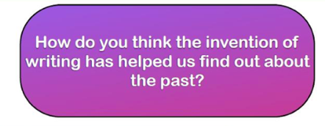  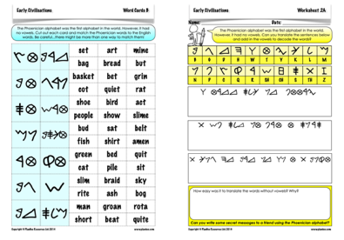  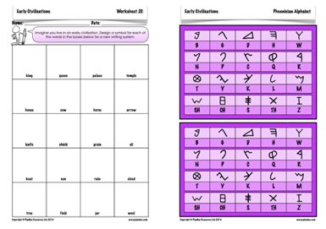  Now make up your own alphabet and then write a message to the class [let me know what it says!]. I will post them and you can decipher each other’s codes.

Website ideas
History ideas:
https://www.bbc.co.uk/teach/class-clips-video/history-ks2-introducing-ancient-sumer/zmgnvk7
https://www.theschoolrun.com/homework-help/ancient-sumer-and-mesopotamia
CBBC: has lots of programmes from ‘Horrible Histories’ to ‘Operation Ouch’
English ideas:
https://www.literacyshed.com/story-starters.html
Online dictionary -https://kids.wordsmyth.net/we/
Pobble 365 Writing activities https://www.pobble365.com/
Maths ideas:
Pixl –practise tables using the App
Nrich -https://nrich.maths.org/primary
Worksheets to practise tables: http://www.snappymaths.com/
Keeping active:
Cosmic kids yoga –mainly on Youtube check with an adult
GoNoodle -https://app.gonoodle.com/
The Woodland trust - https://www.woodlandtrust.org.uk/support-us/act/your-school/resources/ Joe Wicks daily work out

