School Closure Daily Planning- Crystal Class Week 3
DATE | Reading | Writing | Mathematics | Topic
Tuesday  19.1.21  Also listen to story time with Mrs Doe. | Re-read the text from yesterday.Annotate on the text thinking about how it should sound to the audience like we do in class. Can you read it to someone in your family? Give a performance.  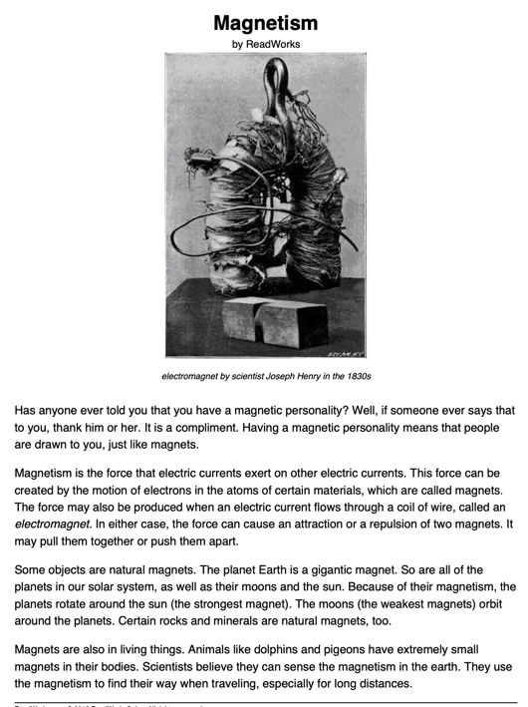 | Finish the story  Story starter!  Jack had been climbing for most of the morning. Step after slippery step, he had made his way up to the top of the beanstalk. Several times, when the wind picked up, he had feared he might lose his footing and fall to his death. He had dared to look down on one occasion, seeing that his house was the size of an ant far below.  Now that he had finally reached his goal and clambered up to the land of the giants, Jack had no idea what to do next.  ‘FEE, FI, FO, FUM…” a voice as loud as a foghorn boomed out from high above him. Jack took a deep breath... | Multiplying 4 digits by 2 digits  Video  https://vimeo.com/488667737  PPT  https://resources.whiterosemaths.com/wp-content/uploads/2020/12/Spr5.2.3-Multiply-4-digits-by-2-digits-basic-practice.pptx  True or False question  https://resources.whiterosemaths.com/wp-content/uploads/2020/12/T-or-F-Year-5-Spring-B1-Multiply-4-digits-by-2-digits-basic-practice.pdf  Activity  https://resources.whiterosemaths.com/wp-content/uploads/2020/12/Y5-Spring-Block-1-WS-Multiply-4-digits-by-2-digits-basic-practice-2020.pdf  Answers  https://resources.whiterosemaths.com/wp-content/uploads/2020/12/Y5-Spring-Block-1-ANS-Multiply-4-digits-by-2-digits-basic-practice.pdf  Challenge  Generate your own sums using increasingly challenging times tables.  Something a little easier  generate your own sums using the times tables 2, 5 and 10. Then include 4 and 8 times tables. | Science  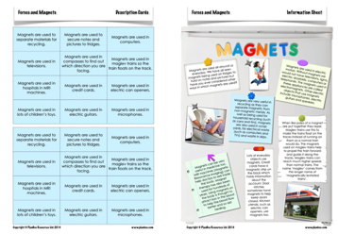  Work through the PPT.  Use the attachment to help organise your thinking. You could create a poster showing the information.

