School Closure Daily Planning- Crystal Class Week 2
DATE | Reading | Writing | Mathematics | Topic
Tuesday  12.1.21 | Re-read the text from yesterday.Annotate on the text thinking about how it should sound to the audience like we do in class. Can you read it to someone in your family? Give a performance. | Sick sentences!  These sentences are ‘sick’ and need help to get better. Can you help? Could you add an adverb?  The Hulk felt hungry. He ate his lunch with the others. He was really big and green. He had a big appetite.  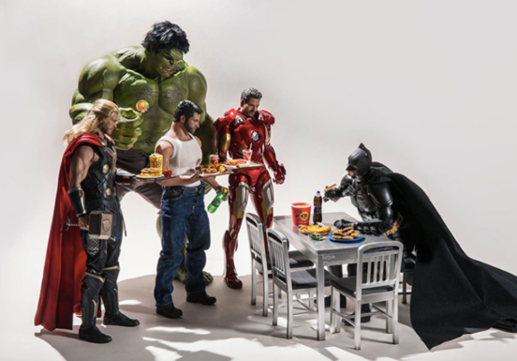  Try to make up your own sentences using a variety of punctuation. | Multiplication  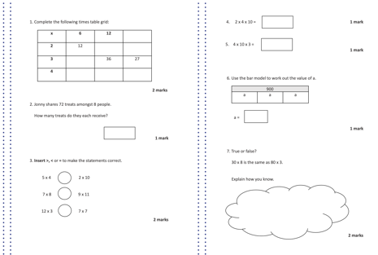  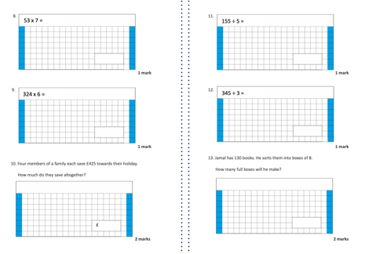  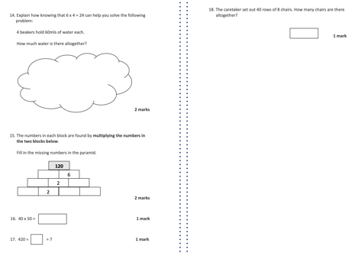 | Science – forces and magnets  Think back to the PPT from yesterday. Use the information to answer some of the statements.  