School Closure Daily Planning- Crystal Class Week 4
DATE | Reading | Writing | Mathematics | PSHE
Thursday 28.1.21 | Answer the following questions on our text.  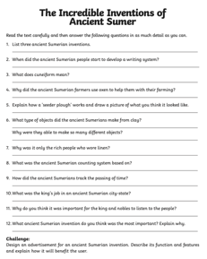 | Continue to plan your myth. Think about:  - What is the plot going to be?  What journey do the characters go on?  What object are they trying to get? | Video  https://vimeo.com/492054148  PPT  https://resources.whiterosemaths.com/wp-content/uploads/2020/12/Spr5.3.4-Divide-with-remainders.pptx  Activity  https://resources.whiterosemaths.com/wp-content/uploads/2019/11/Y5-Spring-Block-1-WO7-Divide-with-remainders-2019.pdf  Answers  https://resources.whiterosemaths.com/wp-content/uploads/2019/11/Y5-Spring-Block-1-ANS6-Divide-4-digits-by-1-digit-2019.pdf  True or False https://resources.whiterosemaths.com/wp-content/uploads/2020/01/T-or-F-Year-5-Spring-Block-1-S7-Divide-with-remainders.pdf  Have a go at some more..  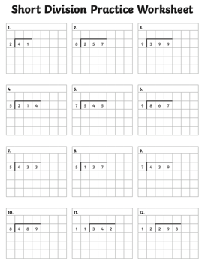 | Watch the online recorded lesson of Mrs Doe click on the link..  https://www.loom.com/share/7f6227b3ee5144d9a866187194304f04  PSHE:  Some of us may be feeling quite angry about all the things we are missing at the moment.  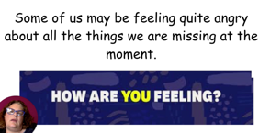  Watch the 2 BBC video about anger. Write down all the words you hear that are linked to being angry.  https://www.bbc.co.uk/bitesize/clips/zxn6n39  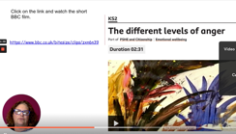  https://www.bbc.co.uk/bitesize/clips/zq676sg  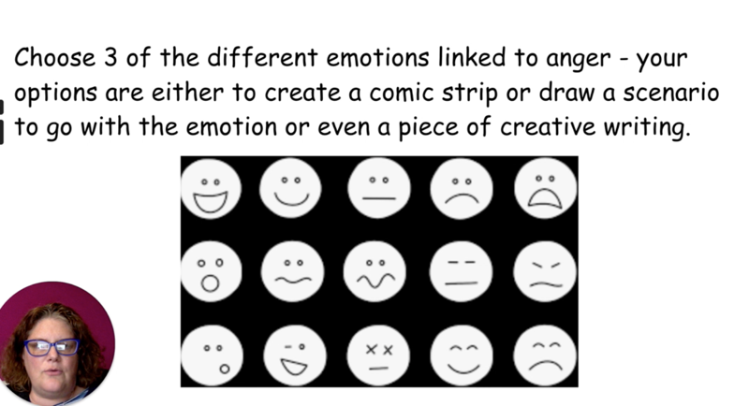

English ideas:
https://www.literacyshed.com/story-starters.html
Online dictionary -https://kids.wordsmyth.net/we/
Pobble 365 Writing activities https://www.pobble365.com/
Maths ideas:
Pixl –practise tables using the App
Nrich -https://nrich.maths.org/primary
Worksheets to practise tables: http://www.snappymaths.com/

Keeping active:
Cosmic kids yoga –mainly on Youtube check with an adult
GoNoodle -https://app.gonoodle.com/
The Woodland trust - https://www.woodlandtrust.org.uk/support-us/act/your-school/resources/
Joe Wicks daily work out

CBBC: has lots of programmes from ‘Horrible Histories’ to ‘Operation Ouch’

