School Closure Daily Planning- Crystal Class Week 3
DATE | Reading | Writing | Mathematics | Topic
Thursday 21.1.21 | Answer the following questions on our text.  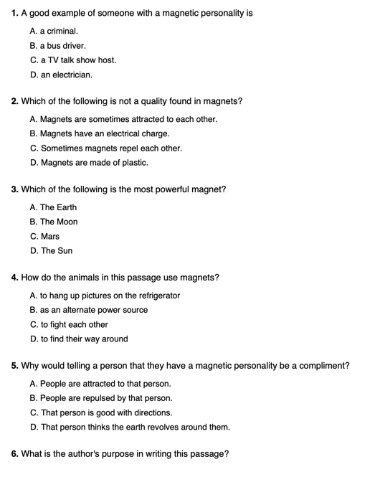 | Perfect picture!  Can you draw a picture of a room inside the giant’s house?  You could draw Jack in the room to put everything into perspective. So Jack is very small and everything is massive in the room.  Talk me through what is in the room – you could lablel items or create a list using bullet points.  Challenge  Imagine you are trying to sell the giant’s house on RightMove. Create an advert that is very persuasive and rather exaggerated. | Divide 2 digit by 1 digit  Video  https://vimeo.com/488870720  Maths PPT  https://resources.whiterosemaths.com/wp-content/uploads/2020/12/Spr5.2.5-Divide-2-digits-by-1-digit-1.pptx  True or False  https://resources.whiterosemaths.com/wp-content/uploads/2020/01/T-or-F-Year-4-Spring-Term-B1-S8-Divide-2-digits-by-1-digit.pdf  Activity  https://resources.whiterosemaths.com/wp-content/uploads/2019/12/Y4-Spring-Block-1-WO8-Divide-2-digits-by-1-digit-1-2019.pdf  Answer  https://resources.whiterosemaths.com/wp-content/uploads/2019/12/Y4-Spring-Block-1-ANS8-Divide-2-digits-by-1-digit-1-2019.pdf  Challenge  Generate your own sums using increasingly challenging times tables.  Something a little easier  generate your own sums using the times tables 2, 5 and 10. Then include 4 and 8 times tables. | PSHE:  It’s quite difficult to be positive at the moment as we are all worried about what is happening and missing people too. Have a go at the negative to positive thoughts activity. Who knows it may even cheer you up!  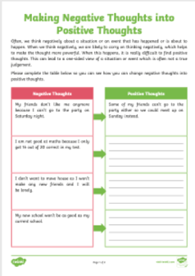  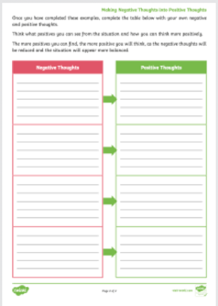

English ideas:
https://www.literacyshed.com/story-starters.html
Online dictionary -https://kids.wordsmyth.net/we/
Pobble 365 Writing activities https://www.pobble365.com/
Maths ideas:
Pixl –practise tables using the App
Nrich -https://nrich.maths.org/primary
Worksheets to practise tables: http://www.snappymaths.com/

Keeping active:
Cosmic kids yoga –mainly on Youtube check with an adult
GoNoodle -https://app.gonoodle.com/
The Woodland trust - https://www.woodlandtrust.org.uk/support-us/act/your-school/resources/
Joe Wicks daily work out

CBBC: has lots of programmes from ‘Horrible Histories’ to ‘Operation Ouch’

