School Closure Daily Planning- Crystal Class Week 2
DATE | Reading | Writing | Mathematics | Topic
Thursday  14.1.21 | Answer the following questions on our text.  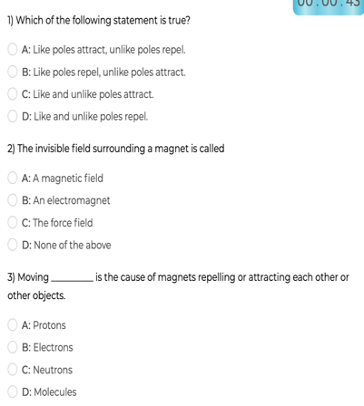  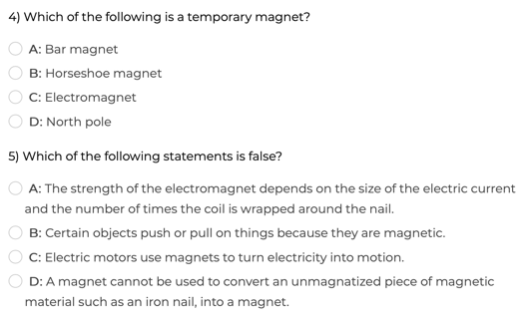 | Sentence challenge!  Can you use relative clauses to add extra information to a sentence using who, which, where, when, whose or that?  E.g. Wolverine, who had recently battled with his arch-enemy, tucked into a hearty lunch.  Batman loved chicken nuggets.  The Hulk enjoyed lollipops.  Make up 5 of your own sentences. | Multiply 2 digits by 2 digits  Video  https://vimeo.com/488553863  PPT  https://resources.whiterosemaths.com/wp-content/uploads/2020/12/Spr5.2.1-Multiply-2-digits-by-2-digits.pptx  True or False  https://resources.whiterosemaths.com/wp-content/uploads/2020/01/T-or-F-Year-5-Spring-Block-1-S3-  Multiply-2-digits-by-2-digits.pdf  Activity  https://resources.whiterosemaths.com/wp-content/uploads/2019/11/Y5-Spring-Block-1-WO3-Multiply-2-digits-by-2-digits-2019.pdf  Answers  https://resources.whiterosemaths.com/wp-content/uploads/2019/11/Y5-Spring-Block-1-ANS3-Multiply-2-digits-by-2-digits-2019.pdf  Challenge  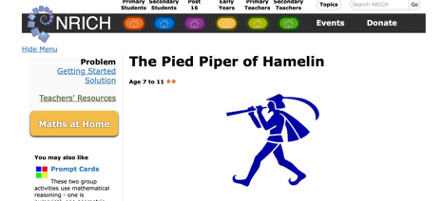  https://nrich.maths.org/1996  Something a bit easier  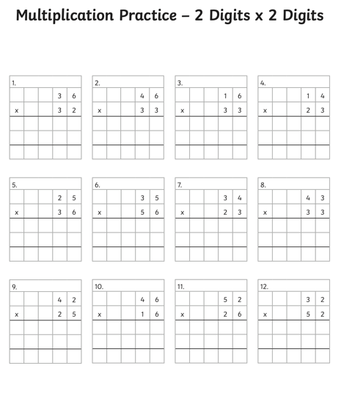 | Science – forces and  magnets.  Work through the  attached PPT.  Also watch BBC Bitesize  KS2 Magnets and their  invisible force.  https://www.bbc.co.uk/bitesize/clips/zk9rkqt  