Squirrel Comprehension
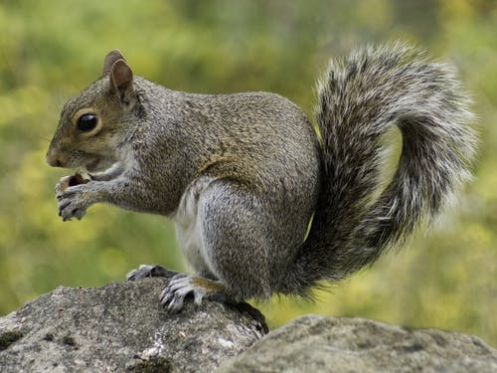
- Write two facts from the text, about a squirrel’s appearance.
-
-
2. List three things that a squirrel likes to eat.
-
-
-
3. Write three facts about a squirrel’s nest:
-
-
-
4. How is a baby squirrel different to an adult squirrel when it is born?

5. Put a cross by the facts that are incorrect:
- Adult squirrels live in pairs.
- You might see a squirrel in your garden.
- Squirrels hibernate.
- Squirrels only have one baby at a time.

