School Closure Daily Planning - Opal Class
DATE | Reading | Writing | Mathematics | Other
Wednesday  06.01.21 | Today is Epiphany. Complete the reading challenge below about this special day: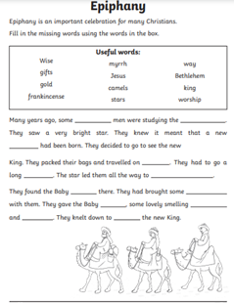  Or:  Read your reading book to an adult and talk to them about any words you don’t understand. Can you find these words in a dictionary and use them in a sentence of your own? | Write some sentences using ‘and’ or ‘because’.  Challenge: Write some sentences beginning with the word ‘When’.  Think carefully about where to start and finish each letter. Remember to use a capital letter to begin each sentence, and a full stop at the end of each. | Watch the White Rose Equal Groups video at:  https://whiterosemaths.com/homelearning/year-2/week-1-number-multiplication-and-division/  Then complete the worksheet below:  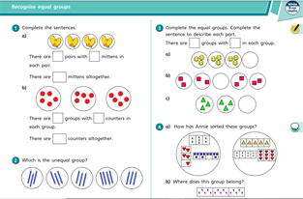 | Wednesday mile challenge! Take your Mum, Dad or carer for a 15-minute jog or walk. Look for signs of spring plants and bulbs beginning to show through the earth.  When you get home, draw a map of your route. What buildings and places did you pass? (Think about when we drew Rosie’s route around the farm!)

