School Closure Daily Planning- Opal Class
DATE | Reading | Writing | Mathematics | Other
Wednesday20.01.21 | Listen to the story of Harris Finds his Feet, again.  Can you find three words in the story that are used instead of ‘said’? Why do you think the author chose to use these words instead of ‘said’?  Can you think of two other words the author might have used to instead of said, at other points in the story? | Write a description of Harris’ grandad.  Use the video on Seesaw, of me modelling a description of Harris, to help you.  Think about these things:  - What are his important features and what are these like?  - What does he do?  - Can you include any similes in your description? | Watch the White Rose video about making doubles at:  https://whiterosemaths.com/homelearning/year-2/spring-week-2-number-multiplication-and-division/  Then complete the worksheets below:  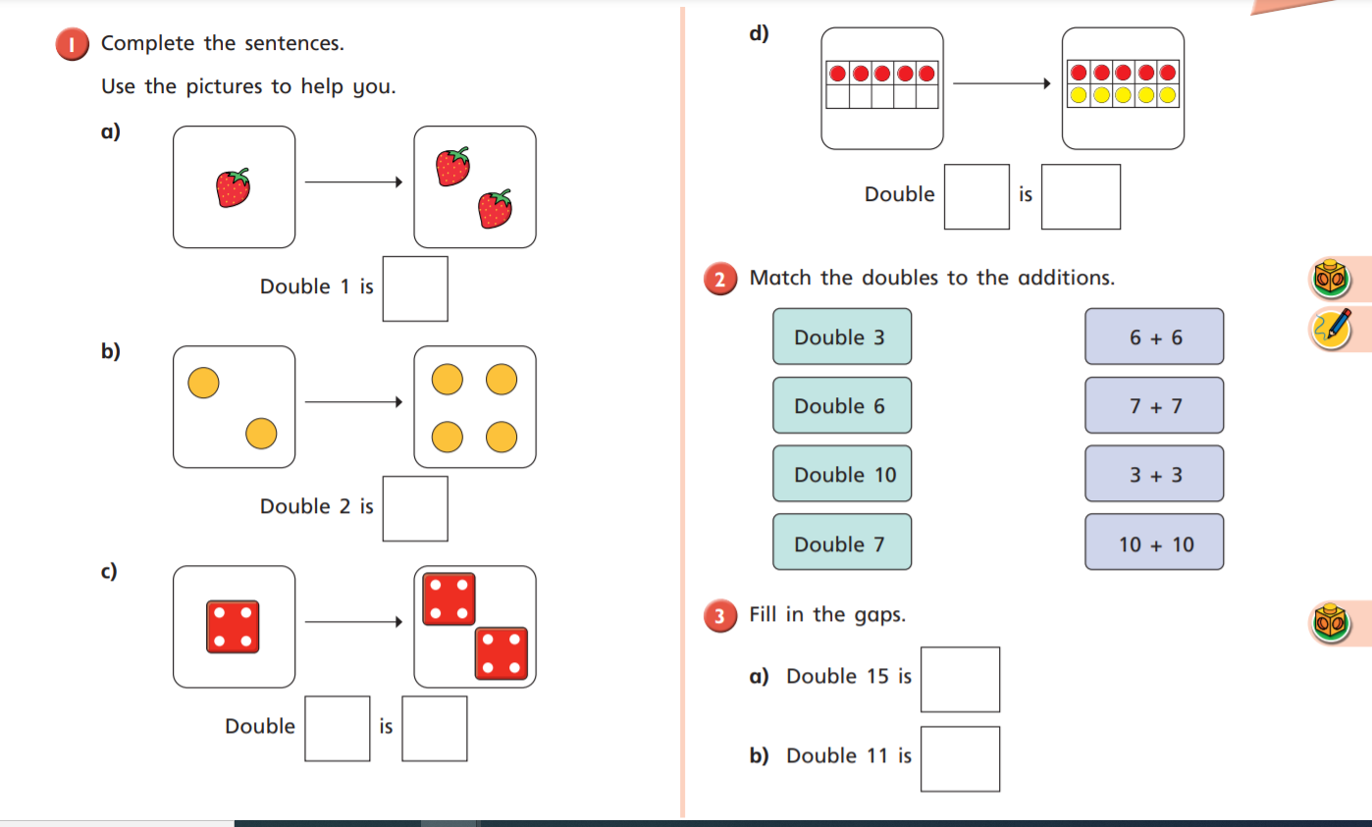  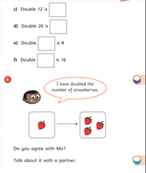 | Go on your Wednesday mile jog  or walk. On the way, look out for the birds on the sheet below:  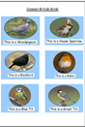  When you get home, tick the ones you saw. Choose your favourite one and make an observational drawing of it. What features will you include? Will you use pencil, pen, paint, pastel?

Here are a few suggestions of websites you may like to browse, for ideas of other home learning activities you could carry out with your children, during this lockdown period. I am sure there are many others available too. As I discover new ones to recommend, I will add to the list.
https://www.bbc.co.uk/bitesize/levels/z3g4d2p
Learning videos, games and activities for children from aged 3-16+
https://home.oxfordowl.co.uk/reading/free-ebooks/
Free ebook library – just sign up!
https://whiterosemaths.com/homelearning/
White Rose home learning resources. Ideal for reinforcing many of the concepts covered last term.
https://www.barefootcomputing.org/homelearning
Lots of activities you can carry out at home with your child, to help them develop skills linked to the ICT curriculum, which don’t actually require screen time. Also, a couple of very good interactive screen time activities provided.
https://www.stem.org.uk/home-learning/primary
Lots of amazing ideas for more science and technology activities.
http://www.robbiddulph.com/draw-with-rob
For those of you who like drawing, some short video lessons, by the illustrator, Rob Biddulph.
https://www.natgeokids.com/uk/teacher-category/primary-resources/
A variety of resources for most curriculum areas.

