School Closure Daily Planning- Opal Class
DATE | Reading | Writing | Mathematics | Other
Wednesday13.01.21 | Listen to the story of Where the Wild Things Are, by Morris Sendak again.  Look up the meaning of the following words from the story.  mischief  vines  rumpus  gnashed | Choose one of the monsters from the picture below. Write at least 4 sentences to describe him. Think about how he looks, how he would sound, how his skin would feel.  - Try to start each one with a different opener such as: He, On, In, His, When.  - Include at least one simile. For example:  His footsteps sounded like rumbles of thunder.  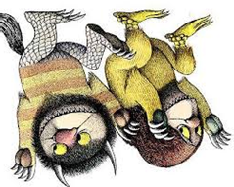  - Don’t forget your punctuation. | Some of the children may find today’s activity quite challenging, so please see the alternative provided below.  Watch the video about multiplication sentences using the x symbol.  https://whiterosemaths.com/homelearning/year-2/week-1-number-multiplication-and-division/  Then complete the worksheet.  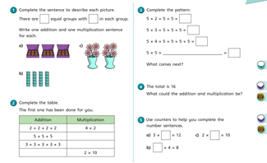  Alternative: Play the game outlined at:  https://www.education.com/download-pdf/activity/13692/  Then, complete the worksheet about counting in 2’s:  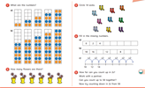 | Go on a Cosmic Yoga Adventure! Follow this link:  https://www.youtube.com/watch?v=uUIGKhG_Vq8&list=PL8snGkhBF7nhTxJt1M7d6A7mmD3kK6wE1&index=2  Go on your Wednesday mile jog or walking challenge. What sort of vehicles pass you, or do you pass? Do you see any lorries, vans, buses, trains, bicycles, motorbikes? Where might they be going? What might they be doing? What is making them work and move?  When you get home, draw a picture of the vehicle you liked best.

Here are a few suggestions of websites you may like to browse, for ideas of other home learning activities you could carry out with your children, during this lockdown period. I am sure there are many others available too. As I discover new ones to recommend, I will add to the list.
https://www.bbc.co.uk/bitesize/levels/z3g4d2p
Learning videos, games and activities for children from aged 3-16+
https://home.oxfordowl.co.uk/reading/free-ebooks/
Free ebook library – just sign up!
https://whiterosemaths.com/homelearning/
White Rose home learning resources. Ideal for reinforcing many of the concepts covered last term.
https://www.barefootcomputing.org/homelearning
Lots of activities you can carry out at home with your child, to help them develop skills linked to the ICT curriculum, which don’t actually require screen time. Also, a couple of very good interactive screen time activities provided.
https://www.stem.org.uk/home-learning/primary
Lots of amazing ideas for more science and technology activities.
http://www.robbiddulph.com/draw-with-rob
For those of you who like drawing, some short video lessons, by the illustrator, Rob Biddulph.
https://www.natgeokids.com/uk/teacher-category/primary-resources/
A variety of resources for most curriculum areas.

