School Closure Daily Planning- Opal Class
DATE | Reading | Writing | Mathematics | Other
Tuesday 19.01.21 | Watch Mrs Tremellen reading the story of ‘Harris finds his feet’.  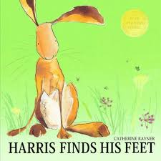  Think of a word you could use, to replace each of these words from the story:  - enormous  - explore  - small  Challenge:  Can you think of a different ending to this simile from the story?  Grandad sat as still as a ……. | Imagine you are Harris, at the moment when the wolf comes. Write 5 sentences to describe this scene.  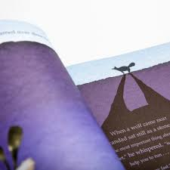  - How do you know he is nearby?  - What are you thinking?  - What are you feeling?  - How is your body reacting?  - What can you hear?  - What do you do? | Harris’s mother has decided she would like to knit her family warm socks for winter. In the family there is Grandad, Mum, Dad, Harris and Harris’s sister. Help her to find out how many socks she must knit, by completing the work sheet on arrays.  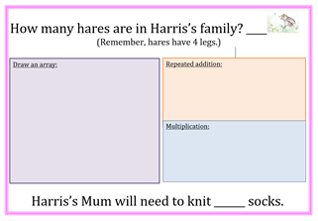  Challenge:  Harris’s neighbours see their new socks, and ask his Mum if she would make some for them too. There are 6 of them in the family. Draw an array to show how many more socks his Mum will need to knit.  How many socks will she have knitted altogether now? | Design a shelter for Harris and his family, to shade them from the hot sun, in summer. Where would you build this shelter? Label your shelter with the materials you would use to build it.

Here are a few suggestions of websites you may like to browse, for ideas of other home learning activities you could carry out with your children, during this lockdown period. I am sure there are many others available too. As I discover new ones to recommend, I will add to the list.
https://www.bbc.co.uk/bitesize/levels/z3g4d2p
Learning videos, games and activities for children from aged 3-16+
https://home.oxfordowl.co.uk/reading/free-ebooks/
Free ebook library – just sign up!
https://whiterosemaths.com/homelearning/
White Rose home learning resources. Ideal for reinforcing many of the concepts covered last term.
https://www.barefootcomputing.org/homelearning
Lots of activities you can carry out at home with your child, to help them develop skills linked to the ICT curriculum, which don’t actually require screen time. Also, a couple of very good interactive screen time activities provided.
https://www.stem.org.uk/home-learning/primary
Lots of amazing ideas for more science and technology activities.
http://www.robbiddulph.com/draw-with-rob
For those of you who like drawing, some short video lessons, by the illustrator, Rob Biddulph.
https://www.natgeokids.com/uk/teacher-category/primary-resources/
A variety of resources for most curriculum areas.

