School Closure Daily Planning- Opal Class
DATE | Reading | Writing | Mathematics | Other
Tuesday 12.01.21 | Listen to Mrs Morris, reading the story of Where the Wild Things Are, by Morris Sendak.  How many of the questions can you answer about the story?  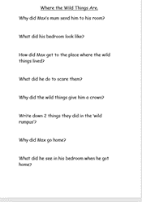  Challenge:  Can you write your answers down? | Think about the order of the story and use the pictures to help you write a different sentence about each stage of the story.  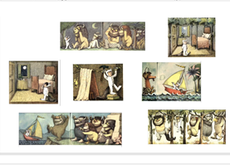  Challenge: Think about how Max is feeling in each picture, and try to include an adjective or an adverb in your sentence to show this. E.g. Angry Max, stomped around his bedroom.  Or Max stomped around his bedroom angrily. | Take 2 dice, (or write 2 sets of numbers 1-6 on small pieces of paper then put each set in a separate pot). Throw the dice (or take one number from each pot). Represent what you have thrown as an equal groups picture, and label it as below. 3 and 2 could be:  3 groups of 2 = 6  6 shared into 3 groups = 2  Repeat this activity a few times. | Design a new boat for Max to travel on, for his second visit to the place where the Wild Things live. Will it be another sail boat or will it be powered in a different way? Perhaps it will be a rowing boat, or a steam boat, or have an engine. Maybe it will even be powered by solar panels! Use your imagination and creative skills!

Here are a few suggestions of websites you may like to browse, for ideas of other home learning activities you could carry out with your children, during this lockdown period. I am sure there are many others available too. As I discover new ones to recommend, I will add to the list.
https://www.bbc.co.uk/bitesize/levels/z3g4d2p
Learning videos, games and activities for children from aged 3-16+
https://home.oxfordowl.co.uk/reading/free-ebooks/
Free ebook library – just sign up!
https://whiterosemaths.com/homelearning/
White Rose home learning resources. Ideal for reinforcing many of the concepts covered last term.
https://www.barefootcomputing.org/homelearning
Lots of activities you can carry out at home with your child, to help them develop skills linked to the ICT curriculum, which don’t actually require screen time. Also, a couple of very good interactive screen time activities provided.
https://www.stem.org.uk/home-learning/primary
Lots of amazing ideas for more science and technology activities.
http://www.robbiddulph.com/draw-with-rob
For those of you who like drawing, some short video lessons, by the illustrator, Rob Biddulph.
https://www.natgeokids.com/uk/teacher-category/primary-resources/
A variety of resources for most curriculum areas.

