School Closure Daily Planning- Opal Class
DATE | Reading | Writing | Mathematics | Other
Thursday  07.01.21 | Listen to the story of Mrs Wobble the Waitress at:  https://www.youtube.com/watch?v=n5i5smhbCZo  Think about the different feelings Mrs Wobble has during the story. Can you make a list of these? | Write a menu for the opening of Mrs Wobble’s café. What special foods will people be able to choose from? Remember to include both savoury and sweet things. What choices will people have to drink? | Watch the White Rose Make Equal Groups video at:  https://whiterosemaths.com/homelearning/year-2/week-1-number-multiplication-and-division/  Then complete the worksheets below:  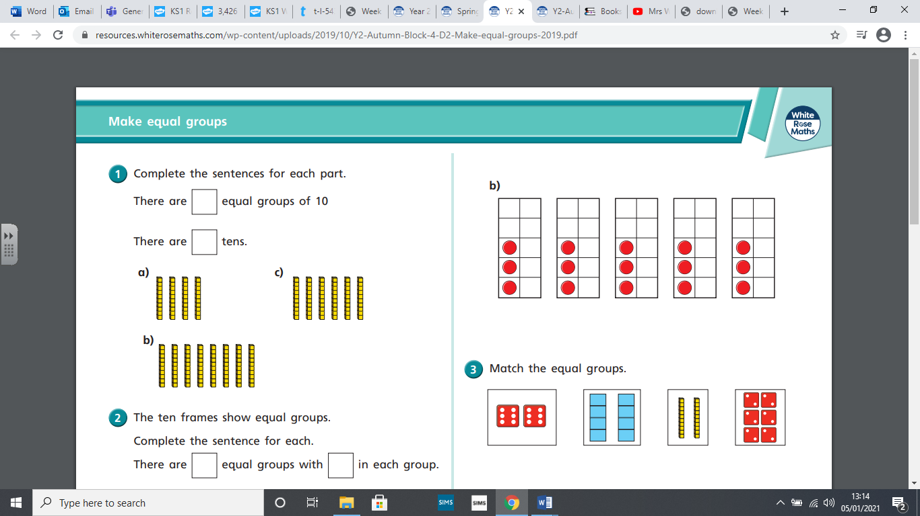  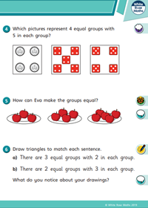 | On a piece of paper draw around a dinner plate and cut it out.  Design a healthy meal plate for Mrs Wobble’s café. What will you include?  You could draw, paint or stick on the things.

