School Closure Daily Planning- Opal Class
DATE | Reading | Writing | Mathematics | Other
Thursday 28.01.21 | If your child is reading at orange level (stage 6) or above, please encourage them to read the second text today, and if they are reading at stages 1-5, please ask them to read the first sheet. Thank you.  Text 1  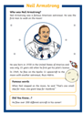  Text 2  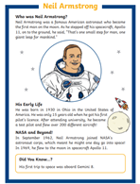  Underline these words:  - astronaut  - licence  What do you think they mean? Look them up in a dictionary, to check if you are correct.  Underline any other vocabulary of which you are unsure. Check these words too. | Complete the appropriate worksheet (or both!).  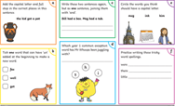Challenge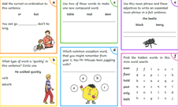 | Watch the video about tally charts and pictograms below:  https://vimeo.com/501671369  Y.1  Make a tally chart for all the shapes in the pictures below, please:  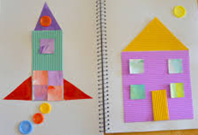  Y.2  complete the worksheet below:  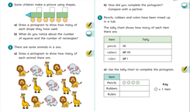  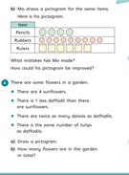 | Listen to the two pieces of music, by clicking on the links below:  https://www.youtube.com/watch?v=qJae3Q2l-BY  https://www.youtube.com/watch?v=nu1TOLObGK8  Both these songs were new and being played around the world, at the time of the moon landing.  - Which did you like best?  - Why?  - What instruments can you see and hear are being played?  - How do you know that these music videos are from a long time ago?

Useful websites for other home learning ideas and activities.

Here are a few suggestions of websites you may like to browse, for ideas of other home learning activities you could carry out with your children, during this lockdown period. I am sure there are many others available too. As I discover new ones to recommend, I will add to the list.
https://www.bbc.co.uk/bitesize/levels/z3g4d2p
Learning videos, games and activities for children from aged 3-16+
https://home.oxfordowl.co.uk/reading/free-ebooks/
Free ebook library – just sign up!
https://whiterosemaths.com/homelearning/
White Rose home learning resources. Ideal for reinforcing many of the concepts covered last term.
https://www.barefootcomputing.org/homelearning
Lots of activities you can carry out at home with your child, to help them develop skills linked to the ICT curriculum, which don’t actually require screen time. Also, a couple of very good interactive screen time activities provided.
https://www.stem.org.uk/home-learning/primary
Lots of amazing ideas for more science and technology activities.
http://www.robbiddulph.com/draw-with-rob
For those of you who like drawing, some short video lessons, by the illustrator, Rob Biddulph.
https://www.natgeokids.com/uk/teacher-category/primary-resources/
A variety of resources for most curriculum areas.

