School Closure Daily Planning- Opal Class
DATE | Reading | Writing | Mathematics | Other
Thursday 21.01.21 | Did you know that today is squirrel appreciation day!  Read the fact sheet about the squirrel:  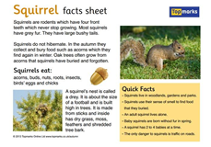  Find the meaning of these words, using a dictionary:  - rodent  - hibernate  Underline any other words of which you are unsure and discuss them with an adult. | Look at the video about a squirrel’s day:  https://www.youtube.com/watch?v=tG_Gz67Crt8  Write at least five sentences about the things a squirrel does in its day. Try to include an exciting verb (doing word), in each one. Maybe you could write it like a diary, as though you are the squirrel. Do you remember on our day in school, after Christmas, when you wrote a diary entry about your Christmas Day?  Challenge:  Can you add interesting adverbs to your sentences?  e.g: I dug rapidly in the dry dirt, to bury my giant acorn. | Watch the White Rose video about making equal groups by sharing at:  https://whiterosemaths.com/homelearning/year-2/spring-week-3-number-multiplication-and-division/  Some Y.2 children may be more comfortable completing the Y. 1 work today. All children doing the Y.1 task, should watch the recap video about sharing into equal groups, instead of the non- recap one.  Y.1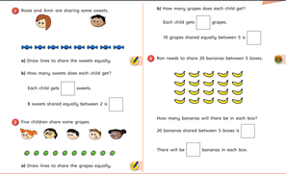  Y.2  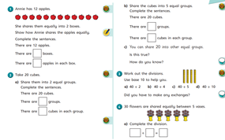 | Go on another Cosmic Yoga adventure! This time, we can remind ourselves how to wash our hands properly.  https://www.youtube.com/watch?v=5rymXdOwW68&list=PL8snGkhBF7nhEquR7wXbzIXjFrlXsze_H&index=19  Make a poster to remind people how to wash their hands properly.

Here are a few suggestions of websites you may like to browse, for ideas of other home learning activities you could carry out with your children, during this lockdown period. I am sure there are many others available too. As I discover new ones to recommend, I will add to the list.
https://www.bbc.co.uk/bitesize/levels/z3g4d2p
Learning videos, games and activities for children from aged 3-16+
https://home.oxfordowl.co.uk/reading/free-ebooks/
Free ebook library – just sign up!
https://whiterosemaths.com/homelearning/
White Rose home learning resources. Ideal for reinforcing many of the concepts covered last term.
https://www.barefootcomputing.org/homelearning
Lots of activities you can carry out at home with your child, to help them develop skills linked to the ICT curriculum, which don’t actually require screen time. Also, a couple of very good interactive screen time activities provided.
https://www.stem.org.uk/home-learning/primary
Lots of amazing ideas for more science and technology activities.
http://www.robbiddulph.com/draw-with-rob
For those of you who like drawing, some short video lessons, by the illustrator, Rob Biddulph.
https://www.natgeokids.com/uk/teacher-category/primary-resources/
A variety of resources for most curriculum areas.

