School Closure Daily Planning- Opal Class
DATE | Reading | Writing | Mathematics | Other
Monday  25.01.21 | Watch the short animation about For the Birds, by following the link below:  https://www.youtube.com/watch?v=nYTrIcn4rjg  Think about the small birds.  - What things do they do? Make a list. | Think about what things the small birds might say to each other in different parts of the story. Write down what you think under each picture:  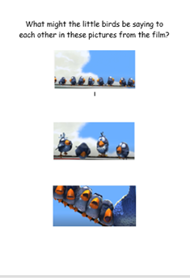 | Today, I would like you to practise your multiplication and division skills by playing Karate Cats online. Follow the link below:  https://www.bbc.co.uk/games/embed/karate-cats-2?exitGameUrl=https%3A%2F%2Fbbc.co.uk%2Fbitesize%2Farticles%2Fzf4sscw  Please choose the Multiplication and Division option, when you get to that point. There are three levels. Start with Bronze, and work up through silver. Gold is very challenging! | Complete today’s Joe Wicks’ workout.  This coming weekend is The RSPB Big Garden Bird Watch. The RSPB are asking for our help to count birds in our gardens over a 1-hour period of time. Although this is a long time to be still and watch, perhaps you could join in for 10 or 15 minutes? To get the free identification sheet you need to sign up online. Could you do this now? You will need an adult to help you. Here is the link:  https://www.rspb.org.uk/get-involved/activities/birdwatch/?sourcecode=BWMITH0230&channel=paidsearch&gclid=EAIaIQobChMIo-qJocie7gIVlJftCh3A8ANSEAAYASAAEgICKvD_BwE

Useful websites for other home learning ideas and activities.

Here are a few suggestions of websites you may like to browse, for ideas of other home learning activities you could carry out with your children, during this lockdown period. I am sure there are many others available too. As I discover new ones to recommend, I will add to the list.
https://www.bbc.co.uk/bitesize/levels/z3g4d2p
Learning videos, games and activities for children from aged 3-16+
https://home.oxfordowl.co.uk/reading/free-ebooks/
Free ebook library – just sign up!
https://whiterosemaths.com/homelearning/
White Rose home learning resources. Ideal for reinforcing many of the concepts covered last term.
https://www.barefootcomputing.org/homelearning
Lots of activities you can carry out at home with your child, to help them develop skills linked to the ICT curriculum, which don’t actually require screen time. Also, a couple of very good interactive screen time activities provided.
https://www.stem.org.uk/home-learning/primary
Lots of amazing ideas for more science and technology activities.
http://www.robbiddulph.com/draw-with-rob
For those of you who like drawing, some short video lessons, by the illustrator, Rob Biddulph.
https://www.natgeokids.com/uk/teacher-category/primary-resources/
A variety of resources for most curriculum areas.

