School Closure Daily Planning- Opal Class
DATE | Reading | Writing | Mathematics | Other
Monday  18.01.21 | Read the real and ‘alien’ words to an adult. 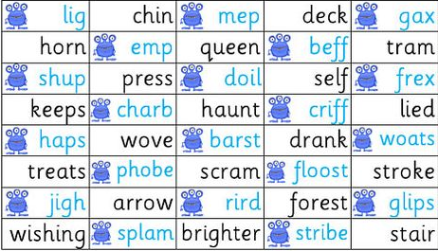  Challenge: choose 4 of the real words and write another real word, with the same ‘special friend’ sound in it, for each one. | Complete the spelling and grammar problems below:  Challenge: | Watch the, White Rose, Using Arrays video at:  https://whiterosemaths.com/homelearning/year-2/spring-week-2-number-multiplication-and-division/  Please stop the video for Year 1 children at 3:50, and complete the following worksheet.  Some of the Year 2 children may find this an appropriate option for today, too.  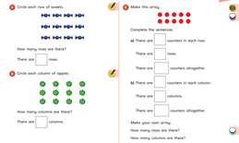  The more challenging alternative, when you have watched to the end of the video is:  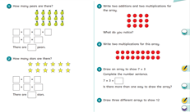 | Complete today’s Joe Wicks’ workout.  Make a simple rain gauge and put it in your garden, so that you can measure the rainfall.  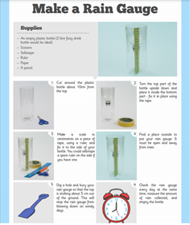  With your windsock, you will have your very own weather station now!

Useful websites for other home learning ideas and activities.

Here are a few suggestions of websites you may like to browse, for ideas of other home learning activities you could carry out with your children, during this lockdown period. I am sure there are many others available too. As I discover new ones to recommend, I will add to the list.
https://www.bbc.co.uk/bitesize/levels/z3g4d2p
Learning videos, games and activities for children from aged 3-16+
https://home.oxfordowl.co.uk/reading/free-ebooks/
Free ebook library – just sign up!
https://whiterosemaths.com/homelearning/
White Rose home learning resources. Ideal for reinforcing many of the concepts covered last term.
https://www.barefootcomputing.org/homelearning
Lots of activities you can carry out at home with your child, to help them develop skills linked to the ICT curriculum, which don’t actually require screen time. Also, a couple of very good interactive screen time activities provided.
https://www.stem.org.uk/home-learning/primary
Lots of amazing ideas for more science and technology activities.
http://www.robbiddulph.com/draw-with-rob
For those of you who like drawing, some short video lessons, by the illustrator, Rob Biddulph.
https://www.natgeokids.com/uk/teacher-category/primary-resources/
A variety of resources for most curriculum areas.

