School Closure Daily Planning- Opal Class
DATE | Reading | Writing | Mathematics | Other
Monday  11.01.21 | Read the ‘alien’ words to an adult. Afterwards, sort them into groups, so that words with the same ‘special friends’ are together.  Challenge: make up another ‘alien’ word for each of the ‘special friends’ groups, write them down, and read them aloud. | Complete the spelling and grammar problems below:  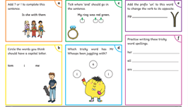  Challenge:  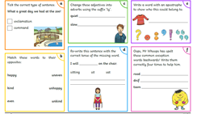 | Watch the White Rose Add Equal Groups video at:  https://whiterosemaths.com/homelearning/year-2/week-1-number-multiplication-and-division/  Then complete the worksheets below:  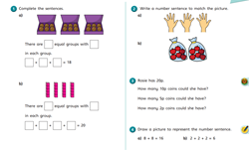  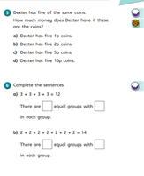 | Complete Joe Wicks’ first workout of the new lockdown.  Make a windsock  Click in the link below to get the instructions of how to make a windsock. You will need an old milk carton and an old plastic bag. Ask an adult to help you cut the milk carton.  When it is ready, tie the windsock up outside, and look at it each day, to see how hard the wind is blowing.  https://nustem.uk/wp/wp-content/uploads/2020/06/SAH-Wind-Sock.pdf

