School Closure Daily Planning- Opal Class
DATE | Reading | Writing | Mathematics | Other
Monday  01.02.21 | Please read the newspaper text below.  Y.1  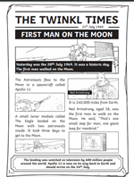  Y.2  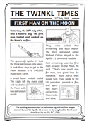  Underline any words of which you are unsure. Can you guess what they mean? Look them up to check. | Today we are going to think about the features of newspaper reports.  Watch my video first, then follow the link below for a story about someone’s awful day:  https://www.youtube.com/watch?v=YuopYOXhiOk  What headline would you write for a newspaper report about Elizabeth’s awful day? | Y.2  Please watch the video below about drawing more challenging pictograms.  https://vimeo.com/504483835  Then complete the worksheet.  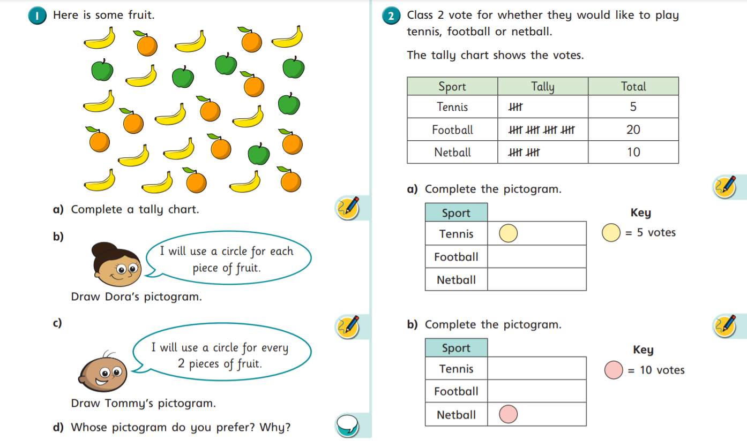  Y.1  Please watch the video below about counting to 50 and then complete the sheet.  https://vimeo.com/500466597  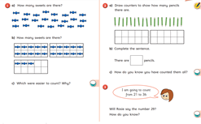 | People around the world were able to watch Apollo 11 take off on TV, either in the comfort of their own living room, or by going to a TV shop window or a communal space, if they didn’t have a TV of their own.  Watch some of them on the video by clicking on the link below:  https://www.youtube.com/watch?v=S3ufJ7lcr08  Compare TVs from 1969 to modernTVs. Add some labels to the 1969 TV and to the 2021 TV to show how they are different. Which do you think you it would be best to watch Apollo 11 take-off on? Why?  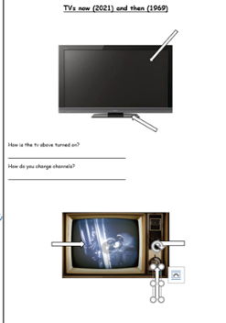

Useful websites for other home learning ideas and activities.
Here are a few suggestions of websites you may like to browse, for ideas of other home learning activities you could carry out with your children, during this lockdown period. I am sure there are many others available too. As I discover new ones to recommend, I will add to the list.
https://www.bbc.co.uk/bitesize/levels/z3g4d2p
Learning videos, games and activities for children from aged 3-16+
https://home.oxfordowl.co.uk/reading/free-ebooks/
Free ebook library – just sign up!
https://whiterosemaths.com/homelearning/
White Rose home learning resources. Ideal for reinforcing many of the concepts covered last term.
https://www.barefootcomputing.org/homelearning
Lots of activities you can carry out at home with your child, to help them develop skills linked to the ICT curriculum, which don’t actually require screen time. Also, a couple of very good interactive screen time activities provided.
https://www.stem.org.uk/home-learning/primary
Lots of amazing ideas for more science and technology activities.
http://www.robbiddulph.com/draw-with-rob
For those of you who like drawing, some short video lessons, by the illustrator, Rob Biddulph.
https://www.natgeokids.com/uk/teacher-category/primary-resources/
A variety of resources for most curriculum areas.

