School Closure Daily Planning - Opal Class
DATE | Reading | Writing | Mathematics | Other
Friday  08.01.21 | Listen to the story of Mrs Wobble again at:  https://www.youtube.com/watch?v=n5i5smhbCZo  Talk about the meaning of the words below, and look them up in a dictionary if you don’t understand them:  customer  manager  fortune  Now write a sentence, of your own, for each word, to show that you understand them. | Handwriting: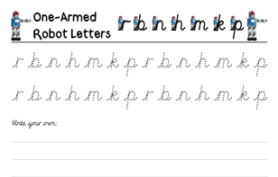  Challenge: | ‘Lots of biscuits’ investigation.  https://nrich.maths.org/6883  You could use real biscuits or other objects to help you complete the challenges in this investigation! | Think back to our topic on materials. Look around your house and garden for things that are made of: glass, fabric, plastic, metal and cardboard. Which group of things can you find most of? Count then all and put the groups in order from the most to the least.  Go on a Cosmic Yoga Adventure! Follow this link:  https://www.youtube.com/watch?v=KAT5NiWHFIU

