School Closure Daily Planning- Opal Class
DATE | Reading | Writing | Mathematics | Other
Friday 15.01.21 | 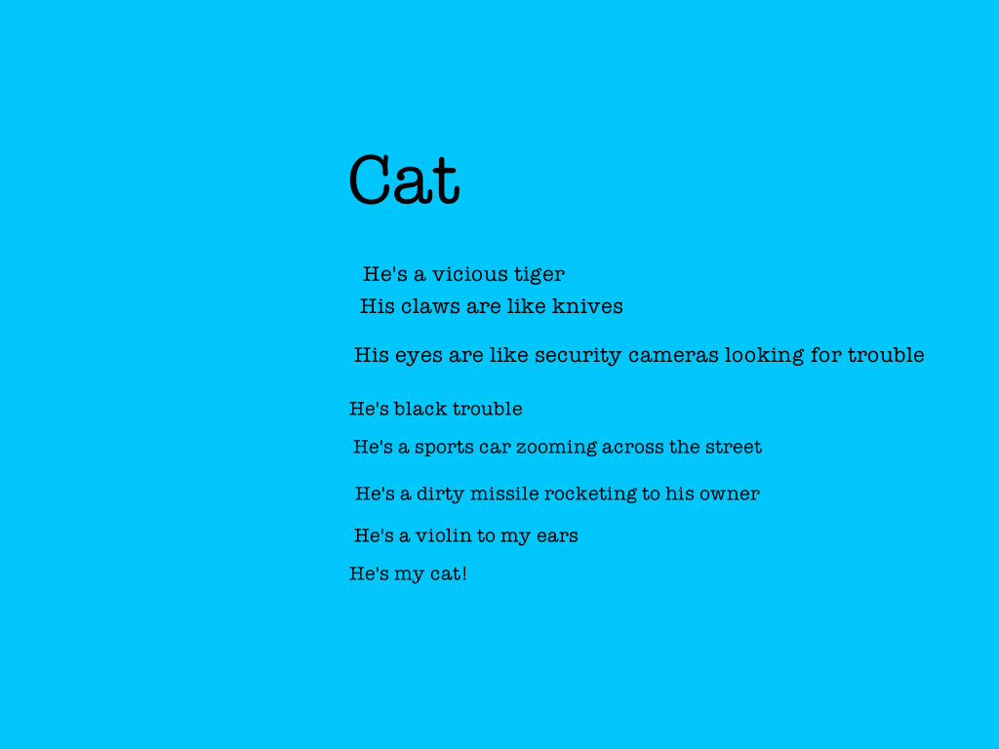  Reread the poem above, and then read the one below:  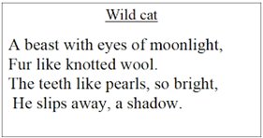  Choose which cat is your favourite, and use the information in the poem about it to draw a picture of it. | Handwriting:  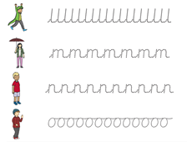  Challenge:  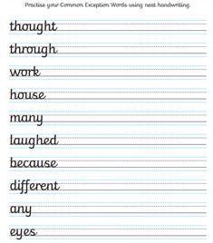  Choose two words from the challenge list and write a  sentence for each one in your neatest handwriting. Make sure you start your letters in the correct place, and make tall letters tall and short letters short! | If your child completed the alternative activity on Wednesday, they might also prefer the alternative activity again today. Please see bottom of column.  Multiplication using pictures:  https://whiterosemaths.com/homelearning/year-2/week-1-number-multiplication-and-division/  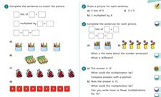  Alternative activity:  Click on the link below to watch the video, then complete the sheet:  https://www.youtube.com/watch?v=BokH3_zaLiA  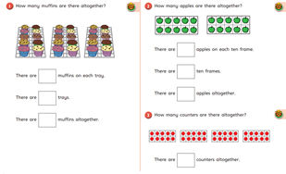 | Take a dance class with Oti Mabusi:  https://youtu.be/y0RGGDusyKI

Here are a few suggestions of websites you may like to browse, for ideas of other home learning activities you could carry out with your children, during this lockdown period. I am sure there are many others available too. As I discover new ones to recommend, I will add to the list.
https://www.bbc.co.uk/bitesize/levels/z3g4d2p
Learning videos, games and activities for children from aged 3-16+
https://home.oxfordowl.co.uk/reading/free-ebooks/
Free ebook library – just sign up!
https://whiterosemaths.com/homelearning/
White Rose home learning resources. Ideal for reinforcing many of the concepts covered last term.
https://www.barefootcomputing.org/homelearning
Lots of activities you can carry out at home with your child, to help them develop skills linked to the ICT curriculum, which don’t actually require screen time. Also, a couple of very good interactive screen time activities provided.
https://www.stem.org.uk/home-learning/primary
Lots of amazing ideas for more science and technology activities.
http://www.robbiddulph.com/draw-with-rob
For those of you who like drawing, some short video lessons, by the illustrator, Rob Biddulph.
https://www.natgeokids.com/uk/teacher-category/primary-resources/
A variety of resources for most curriculum areas.

