School Closure Daily Planning- Opal Class
DATE | Reading | Writing | Mathematics | Other
Friday  29.01.21 | Reread the text from yesterday, then answer the comprehension questions related to this:  Text 1  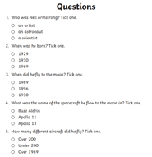  Text 2  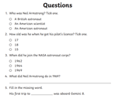 | Handwriting and spelling:  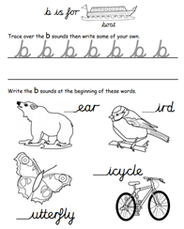  Think of some more words with the special friend ‘ir’ in them and write these in a list in alphabetical order.  Challenge  Trace over the word first, before you write your own. When you have finished, choose two of the spellings and make a spelling pyramid for each.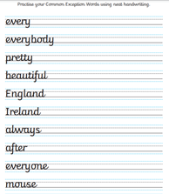 | Y.2  Watch the video about interpreting pictograms below:  https://vimeo.com/501674074  Then complete the sheets below:  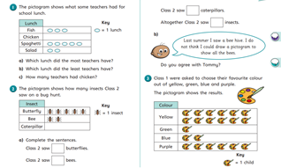  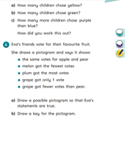  Y.1  Please play the fruit fall game, to practise making pictograms and interpreting them.  http://toytheater.com/fruit-fall/ | Take a Cosmic yoga class by following the link below: https://www.youtube.com/watch?v=LhYtcadR9nw  Spend as long as you can tallying the birds in your garden for the Big Garden Bird Watch survey. If you manage a whole hour, you will be able to send in your data to the RSPB! This will help them understand how well the birds in Great Britain are thriving this winter. (You will probably need an adult to help you with this activity.)

Useful websites for other home learning ideas and activities.
Here are a few suggestions of websites you may like to browse, for ideas of other home learning activities you could carry out with your children, during this lockdown period. I am sure there are many others available too. As I discover new ones to recommend, I will add to the list.
https://www.bbc.co.uk/bitesize/levels/z3g4d2p
Learning videos, games and activities for children from aged 3-16+
https://home.oxfordowl.co.uk/reading/free-ebooks/
Free ebook library – just sign up!
https://whiterosemaths.com/homelearning/
White Rose home learning resources. Ideal for reinforcing many of the concepts covered last term.
https://www.barefootcomputing.org/homelearning
Lots of activities you can carry out at home with your child, to help them develop skills linked to the ICT curriculum, which don’t actually require screen time. Also, a couple of very good interactive screen time activities provided.
https://www.stem.org.uk/home-learning/primary
Lots of amazing ideas for more science and technology activities.
http://www.robbiddulph.com/draw-with-rob
For those of you who like drawing, some short video lessons, by the illustrator, Rob Biddulph.
https://www.natgeokids.com/uk/teacher-category/primary-resources/
A variety of resources for most curriculum areas.

