School Closure Daily Planning- Crystal Class Week 5
DATE | Reading | Spelling/Writing | Mathematics | Topic
Monday 1st February  Monday morning welcome with Mrs Doe.  https://www.loom.com/share/4cb4ad8074434fb396415ab8e2193bf3 | 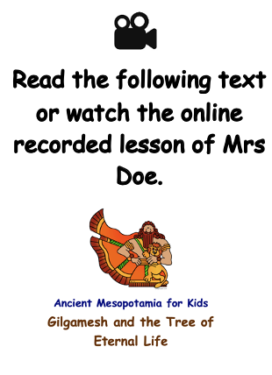  https://www.loom.com/share/1c69ef4be6034025811450b73c153990 | 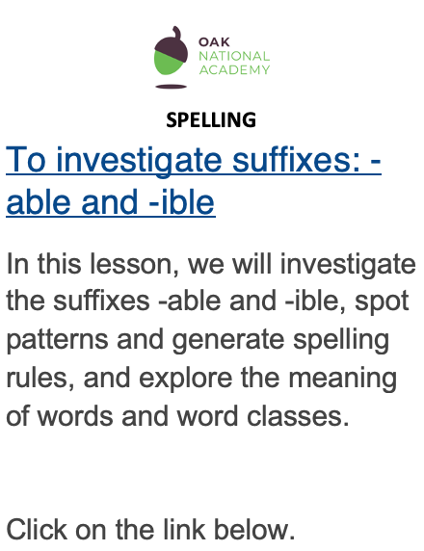  https://classroom.thenational.academy/lessons/to-investigate-suffixes-able-and-ible-69h6at  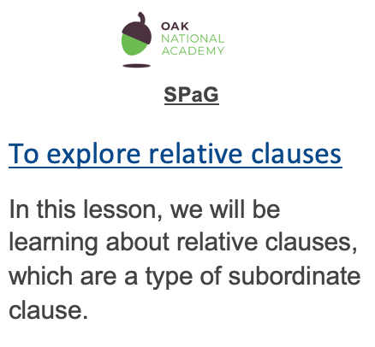  Click on the link below:  https://classroom.thenational.academy/lessons/to-explore-relative-clauses-65k30c | Mathletics or the suggested links below – Statistics and Data Handling - reading tables.  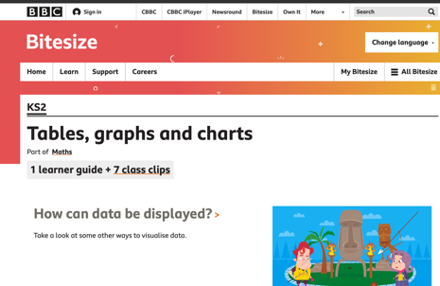  https://www.bbc.co.uk/bitesize/topics/z7rcwmn  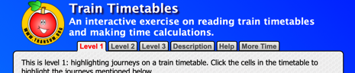  https://www.transum.org/Maths/Exercise/Timetables.asp | Who were the Sumerians?  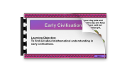  Lesson 4  To find out about mathematical understanding in early civilisations.  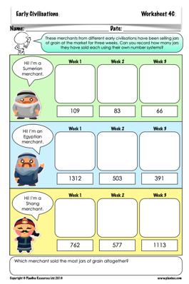  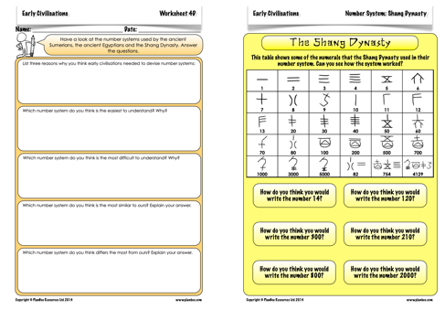  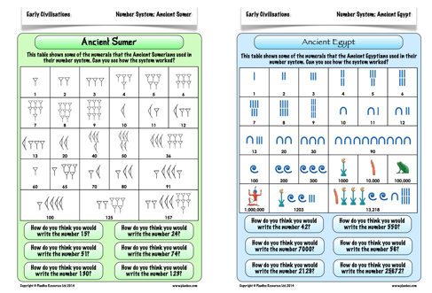

History ideas:
https://www.bbc.co.uk/teach/class-clips-video/history-ks2-introducing-ancient-sumer/zmgnvk7
https://www.theschoolrun.com/homework-help/ancient-sumer-and-mesopotamia
CBBC: has lots of programmes from ‘Horrible Histories’ to ‘Operation Ouch’

English ideas:
https://www.literacyshed.com/story-starters.html
Online dictionary -https://kids.wordsmyth.net/we/
Pobble 365 Writing activities https://www.pobble365.com/
Maths ideas:
Pixl –practise tables using the App
Nrich -https://nrich.maths.org/primary
Worksheets to practise tables: http://www.snappymaths.com/
Keeping active:
Cosmic kids yoga –mainly on Youtube check with an adult
GoNoodle -https://app.gonoodle.com/
The Woodland trust - https://www.woodlandtrust.org.uk/support-us/act/your-school/resources/
Joe Wicks daily work out

