School Closure Daily Planning- Crystal Class Week 3
DATE | Reading | Spelling/Writing | Mathematics | Topic
Monday 18.1.21  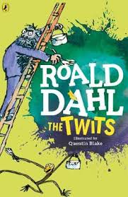  Also listen to story time with Mrs Doe. | Read the following text or listen to the recording of it.  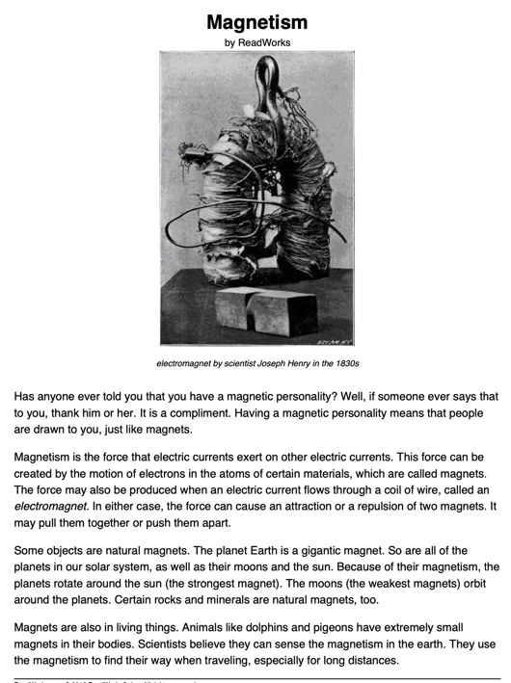 | SPELLING  Watch the live lesson.  In this lesson, we will investigate homophones in detail, learn what homophones are, and explore the meaning of words in depth, spotting spelling rules.  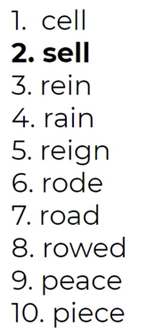  https://teachers.thenational.academy/units/homophones-near-homophones-5807#  WRITING  Refresh your memory of Jack and the beanstalk.  - See if you can watch the David Walliams version that was on over Christmas on Sky.  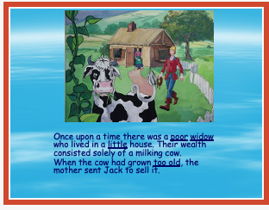  - Or read through the attached PPT.  Top of the beanstalk  Question time!  Has the giant seen Jack?  How might Jack feel at this moment?  Would you rather be the giant or Jack?  Would you rather be a giant in a land of humans, or a human in a land of giants?  What/who else lives in the land of the giants?  Why do giants live apart from humans | Mathletics or Top Marks – focus multiplication and division recap. | Work through the PPT and try to carry-out the experiment. Hopefully you have a magnet somewhere around your home. Do the best you can.:)  