School Closure Daily Planning- Garnet Class
DATE | Reading | Writing | Mathematics | Other
Monday  11.1.21 | Read and understand the text  Please can you read the text on the explorer Ernest Shackleton and then practise reading it out loud to someone in your family.  Extension  Read more about Ernest Shackleton and the Antarctica  https://kids.kiddle.co/Ernest_Shackleton  https://www.kids-world-travel-guide.com/antarctica-facts.html | Spellings  The Oak Academy exploring plurals Lesson 1  https://classroom.thenational.academy/units/suffixes-plural-0d5b  Follow the lesson from The Oak Academy and then look at the additional words from our statutory spellings. Can you practise both sets of words.  If you are unsure of any meanings please check in a dictionary.  https://kids.wordsmyth.net/we/ | Pixl test: Please complete the test and mark your work  Mathletics: Groups of 7 and dividing 7  Please contact me if you need log in details for Mathletics.  Extension  Pixl tables app, top marks and maths frame -7s, 11s and 12 times tables. | 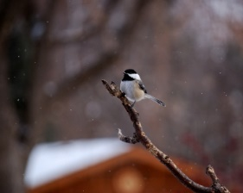  Activity  Go for a walk with a grown-up or sit at a window with a view of a garden. What animals and plants can you see? Draw or describe what you see. You could use the Internet to research the names of what you find. Remember to search safely and check with an adult.

More ideas to help with home learning
Writing ideas:
https://www.literacyshed.com/story-starters.html
Online dictionary -https://kids.wordsmyth.net/we/

Maths ideas:
Pixl –practise tables using the App
Nrich -https://nrich.maths.org/primary
Worksheets to practise tables: http://www.snappymaths.com/

Keeping active:
Cosmic kids yoga –mainly on Youtubecheck with an adult
GoNoodle -https://app.gonoodle.com/
The Woodland trust - https://www.woodlandtrust.org.uk/support-us/act/your-school/resources/
Joe Wicks daily work out

