School Closure Daily Planning- Crystal Class
DATE | Reading | Writing | Mathematics | Topic
Monday | 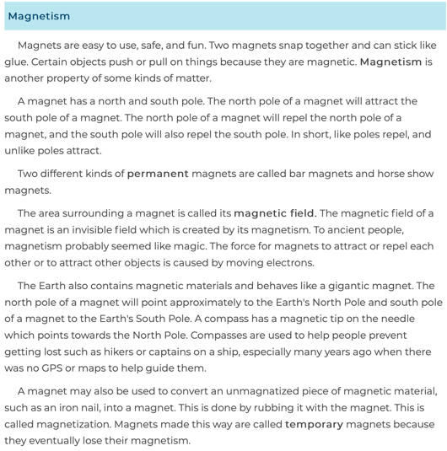  Read the following text.  Wordsearch added for fun and to support you with the language linked to our science learning this week.  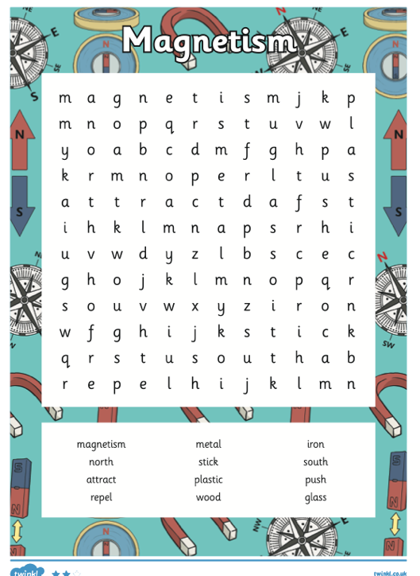 | 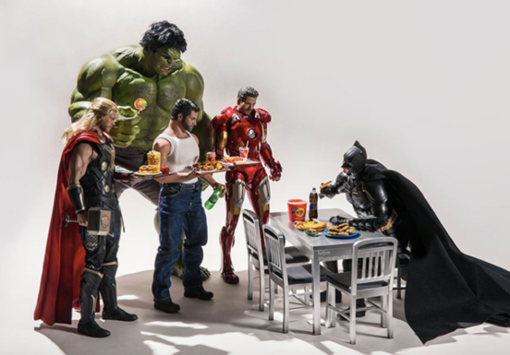  Question time!  Can you recognise each of the characters?  What do you think each of them do on a daily basis?  What do you think each of their favourite foods might be?  What do you think each of the characters are really like? | Mathletics or Top Marks – focus multiplication and division recap. | 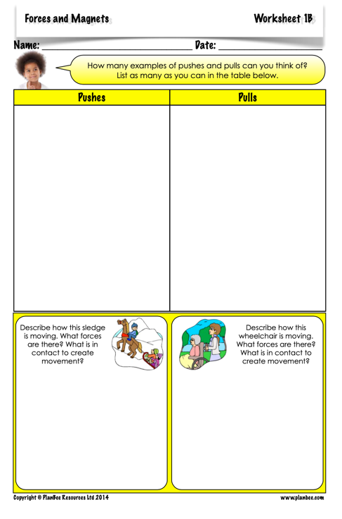  Science – forces and magnets  Use attached PPT for science.  .

Remember to keep up to date with topical events by watching BBC Newsround.

