TVs now (2021) and then (1969)

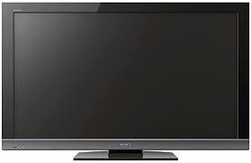

How is the tv above turned on?
______________________________________
How do you change channels?
______________________________________

What is similar about the TVs?
_____________________________________________________________________
What is different about them?
_____________________________________________________________________

