School Closure Daily Planning- Garnet Class
DATE | Reading | Writing | Mathematics | Topic
Friday  8.1.21 | Answer questions from the text. Can you remember to answer in full and remember sentences start with a …  - Where was the old man sitting?  - Find and copy two words that the author uses which mean the same as hair.  - Give one way that the two characters are similar and one way that they are different.  - Who do you think the old man is? Who do you think the young man is? Explain your answers. | 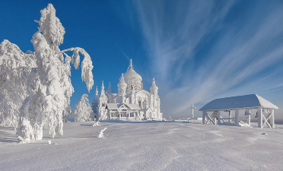  The Frozen Palace  Story starter!  Once, this place had been filled with colour and sunshine. Once, this place had seen thousands of people come and go. Once, this had been the happiest of places, filled with laughter and joy.  Now, everything was cold. Everyone was gone. Well, almost everyone…  Can you continue the story? What has happened to the palace? Who is it that remains?  Can you remember some of the wintry details and ideas from’Pugs of the Frozen North’ to help you?  Remember your presentation and a title. Could you draw a story mountain to help you plan?  - Introduction  - Build up  - Problem  - Resolution (solving the problem)  - Ending  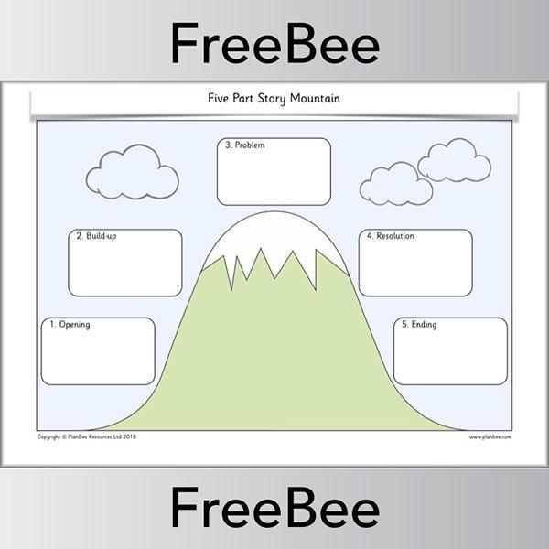 | Length and Perimeter  Please watch the video from White Rose Maths  Recap lesson on measure  https://whiterosemaths.com/homelearning/year-4/week-8-measurement-length-perimeter/  Please follow the link to watch the video on White Rose Maths.  Can you answer the questions at the start of the video and from the worksheet too? | Dance  Go Noodle winter dances –just follow the link.  https://app.gonoodle.com/activities/winter-wonderland?sp=search&sn=search&st=video%20versions&sid=1008

