School Closure Daily Planning- Crystal Class Week 4
DATE | Reading | SPaG/Writing | Mathematics | Topic
Friday 29.1.21  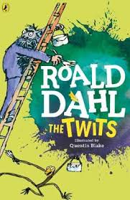  Also listen to story time with Mrs Doe. | Mark the answers from yesterday. How did you do?  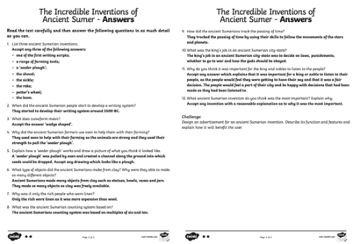 | Spelling  Watch the live lesson.  https://teachers.thenational.academy/units/homophones-d8a4#  In this lesson, you will practise and apply our knowledge of homophones. | Watch the online recorded lesson of Mrs Doe – click on the link.  https://www.loom.com/share/651953b4eb4447909a70183d38e6dc13  Work through the PPT and questions.  Recap  https://www.bbc.co.uk/bitesize/topics/z36tyrd/articles/zgxdfcw | Lesson 2  https://www.youtube.com/watch?v=uYyvkI0tpnk

Other useful websites:
English ideas:
https://www.literacyshed.com/story-starters.html
Online dictionary -https://kids.wordsmyth.net/we/
Pobble 365 Writing activities https://www.pobble365.com/
Maths ideas:
Pixl –practise tables using the App
Nrich -https://nrich.maths.org/primary
Worksheets to practise tables: http://www.snappymaths.com/

Keeping active:
Cosmic kids yoga –mainly on Youtube check with an adult
GoNoodle -https://app.gonoodle.com/
The Woodland trust - https://www.woodlandtrust.org.uk/support-us/act/your-school/resources/
Joe Wicks daily work out

CBBC: has lots of programmes from ‘Horrible Histories’ to ‘Operation Ouch’

