School Closure Daily Planning- Crystal Class Week 3
DATE | Reading | SPaG/Writing | Mathematics | Topic
Friday 22.1.21  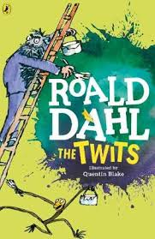  Also listen to story time with Mrs Doe. | Mark the answers from yesterday. How did you do?  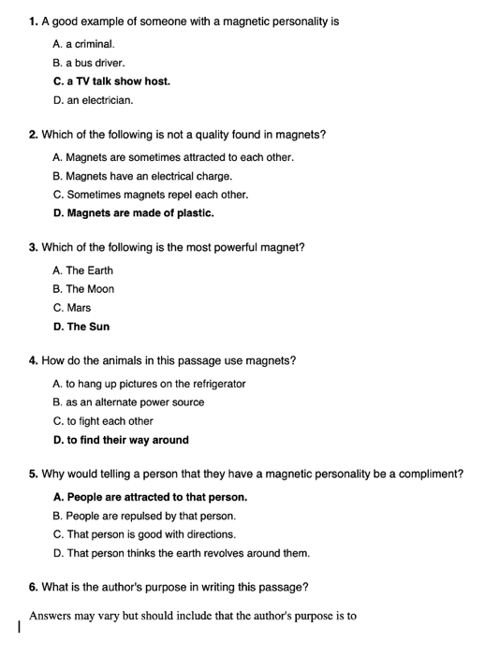  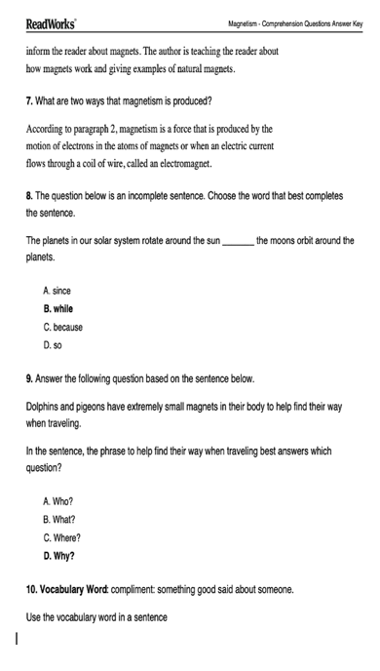 | SPELLING  Watch the live lesson.  In this lesson, we will review homophones and spelling rules from the last spelling lesson. We will use an exciting new strategy to help us remember our spelling words and a spelling test at the end of the lesson.  https://teachers.thenational.academy/units/homophones-near-homophones-5807#  Sick sentences!  These sentences are ‘sick’ and need help to get better. Can you help?  - Jack climbed the beanstalk.  - The giant stood at the top.  - Jack was scared.  - The giant was really big.  - The giant had large feet.  - The beanstalk was green.  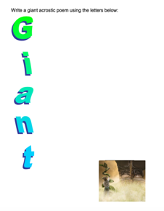  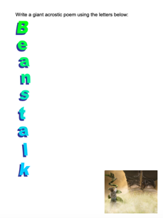  Poetry – create an acrostic for the words GIANT and BEANSTALK. Try to use the vocabulary from your work this week. | Divide 2 digit by 1 digit  Video  https://vimeo.com/492054019  PPT  https://resources.whiterosemaths.com/wp-content/uploads/2020/12/Spr5.3.1-Divide-2-digits-by-1-digit-2.pptx  Activity  https://resources.whiterosemaths.com/wp-content/uploads/2019/11/Y4-Spring-Block-1-WO9-Divide-2-digits-by-1-digit-2-2019.pdf  Answers  https://resources.whiterosemaths.com/wp-content/uploads/2019/11/Y4-Spring-Block-1-ANS9-Divide-2-digits-by-1-digit-2-2019.pdf  Challenge  Generate your own sums using increasingly challenging times tables.  Something a little easier  generate your own sums using the times tables 2, 5 and 10. Then include 4 and 8 times tables. | https://youtu.be/CflrJ4y-Z7g  First lesson from Chance to shine – it was live on 13/1/21 but we will join it as a catch up.  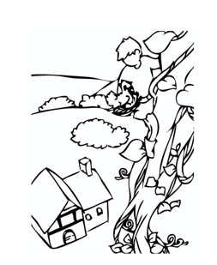  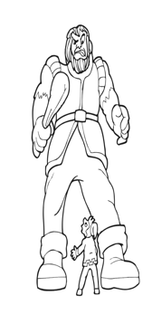

Other useful websites:
English ideas:
https://www.literacyshed.com/story-starters.html
Online dictionary -https://kids.wordsmyth.net/we/
Pobble 365 Writing activities https://www.pobble365.com/
Maths ideas:
Pixl –practise tables using the App
Nrich -https://nrich.maths.org/primary
Worksheets to practise tables: http://www.snappymaths.com/

Keeping active:
Cosmic kids yoga –mainly on Youtube check with an adult
GoNoodle -https://app.gonoodle.com/
The Woodland trust - https://www.woodlandtrust.org.uk/support-us/act/your-school/resources/
Joe Wicks daily work out

CBBC: has lots of programmes from ‘Horrible Histories’ to ‘Operation Ouch’

