School Closure Daily Planning- Crystal Class Week 2
DATE | Reading | Writing | Mathematics | Topic
Friday  15.1.21 | Mark the answers from yesterday. How did you do?  Now using your own book that ypu are currently reading complete a couple of the tasks  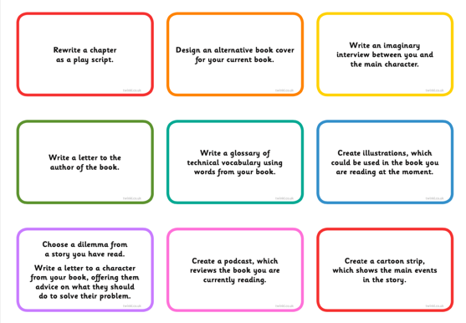 | Perfect picture!  Can you draw the perfect -posh- lunch for superheroes? Think carefully about what they would eat.  Starter  Main  Pudding  Drink  Why not present it like a posh menu and decorate with a superhero border.  Would each superhero eat the same?  What Might Batman have if chicken nuggets weren’t on the menu?  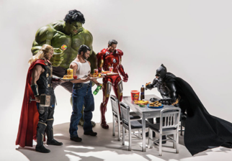 | Multiply 3 digits by 2 digits  Video  https://vimeo.com/488555095  PPT  https://resources.whiterosemaths.com/wp-content/uploads/2020/12/Spr5.2.2-Multiply-3-digits-by-2-digits.pptx  True or False  https://resources.whiterosemaths.com/wp-content/uploads/2020/01/T-or-F-Year-5-Spring-Block-1-S4-Multiply-3-digits-by-2-digits.pdf  Activity  https://resources.whiterosemaths.com/wp-content/uploads/2019/11/Y5-Spring-Block-1-WO4-Multiply-3-digits-by-2-digits-2019.pdf  Answers  https://resources.whiterosemaths.com/wp-content/uploads/2019/11/Y5-Spring-Block-1-ANS4-Multiply-3-digits-by-2-digits-2019.pdf  Challenge  https://nrich.maths.org/84/index  Something a bit easier  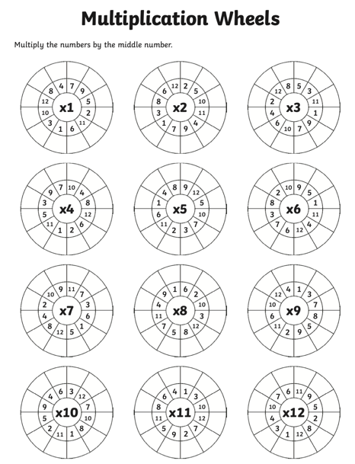 | P.E Just Dance  Continue to learn Bangarang.  https://www.youtube.com/results?search_q  uery=just+dance+bangarang

